Adswood Primary School
Newsletter

November 2023
Dear Parents/Carers,
Welcome back! How time flies! The countdown to Christmas begins!
Lots of exciting days ahead for our children in school.
New class themes are underway and home learning will be sent out this week. Our website explains our curriculum in more detail and includes learning for each year group. Take a look!
Ask your child about their new theme – how can you support their learning at home?
This term our theme week is ‘My Digital World’ with a focus on computing and the safe use of the internet.
Green Day for Khia - Thank you to all who donated on the last day of half term for the Mc Donald House who have provided support for Khia’s family on his road to recovery. We raised £234. Well done and thank you.
Our Aspirations Week in school before half term was a huge success with children discussing their hopes and dreams for the future. Each morning the children started the day with an assembly delivered by a range of visitors to school including two inspiring artists. The children were so respectful and the feedback from children’s voice at the end of the week was extremely positive – they had learnt so much and had become more knowledgeable about what the future may hold! Thank you to Miss Syddall for organising the week.
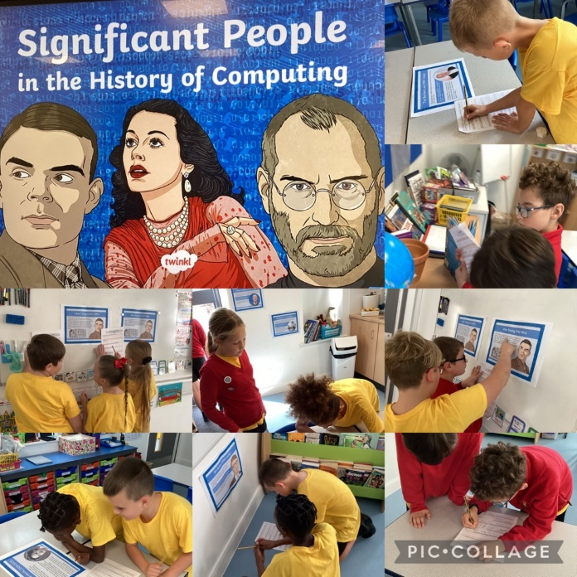

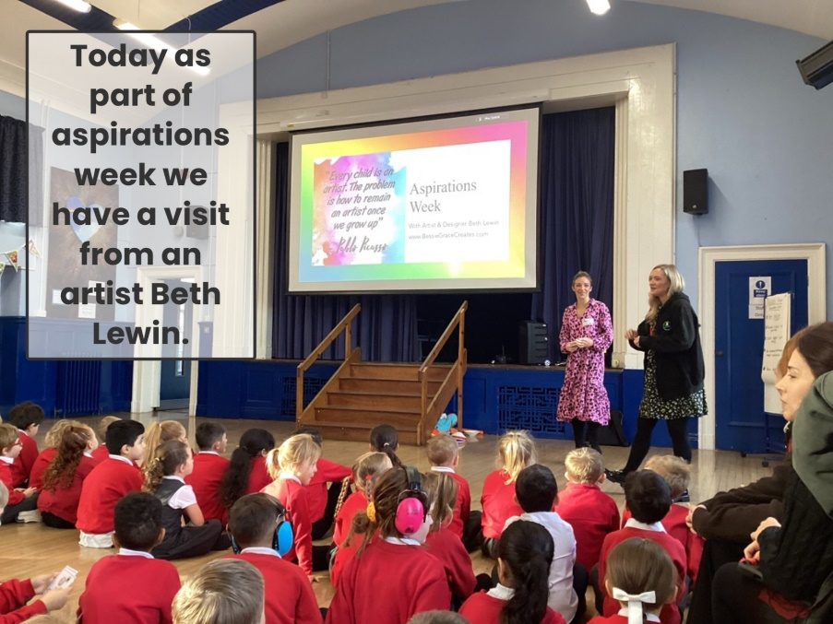

Our Halloween Disco was a huge success! The children had a wonderful time at the disco with games and prizes to be won! We will be hosting a Valentines Disco for the juniors in the New Year. Thank you for supporting the school.
Starlight Club (After School Club provision) NEW from January 2024!
From January 2024 we will be launching our new after school club to support our working families. The club will run each night from 3.15-5.45pm (Fridays -5pm) on our school site. More details will be sent out over the next month. We are aware that a number of families use ‘More Play More Often’our current provider at Alexandra Park, Edgeley. If you wish for your child to attend our new school provision then you will need to give MPMO advance notice. If you have any questions please contact Mrs Smart.
Enjoy, Believe, Achieve Awards
We are now 3 years into our EBA awards with some children already receiving stickers for their work towards an award. Our work has been celebrated in the Authority for being a leading primary school introducing a life skills curriculum that is unique to Adswood.
Reading
We have purchased a range of non-fiction books for our reading stations around school thank you to your kind donations from the Summer fair back in June. These stations are now clearly labelled and organised and are being used by the children to aid learning in class.
Subject Leaders in our school
We have staff who lead a subject in school and work with other staff to ensure our children receive the best possible education in that subject through their primary years. If you wish to know any more about our subject’s please take a look at our website where you will see detailed information about how we teach these subjects in our school.
The table below is our subject leads –
Curriculum | Mrs Lennon
EYFS | Miss Hulmes
Maths | Miss Edwards and Mrs Santer
English | Miss Richardson /Miss McFayden
Science | Miss Harvey
Computing | Miss Hulmes
Design and Technology | Miss Harvey
Art and Design | Miss Gregory
PE | Mr Smith
History/Geography | Mr Davies
PSHE | Mrs Smith
Music | Miss Syddall
RE | Mrs Lennon
Modern Foreign Language | Mrs Holland
Special Educational Needs | Mrs Gee
Pastoral and Care Manager | Mr Clarke

Coming up…

- Poetry Workshop for Year 6 –Tuesday 31st October
- PHOTOGRAPH DAY – Friday 3rd November
- Chester Zoo Workshops – Year 3 and Year 5 – Tuesday 7th November
- Safe online workshop for any parent/carer that would like to attend – find out more about the apps and how to keep your child safe online. (A very important workshop for all) Tuesday 7th November at 2pm – Please ring the school office or call in to book a place
- Water Aid presentation to Year 6 – Friday 10th November
- Maths Week- Monday 13th November for the whole school
- Children In Need – Friday 17th November . Wear something spotty for the day with non-uniform!
- Bingo Night! 21st November 7.30pm – POSTPONED - We have decided to move this event to the Spring Term with Christmas fast approaching.
- Crucial Crew – Year 6 Tuesday 21st November 9.30am
- Non uniform – please donate bottle for the Xmas Fair – Thursday 23rd November
- INSET DAY – Friday 24th November

Each class team will continue to send out a class blog to inform you of the learning that will take place each week in your child’s classroom in addition to any further key information that you may need.

Please do not hesitate to come into school if you have any questions or queries.

Here’s to a fantastic half term!

Thank you for your continued support.

M Smart and the Adswood Team.

