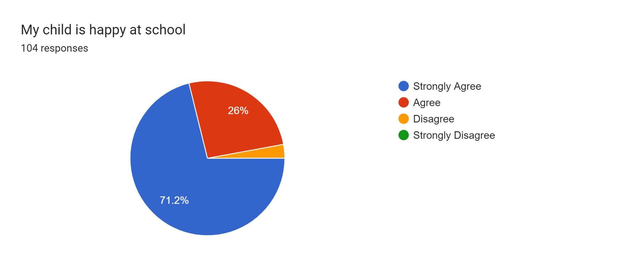
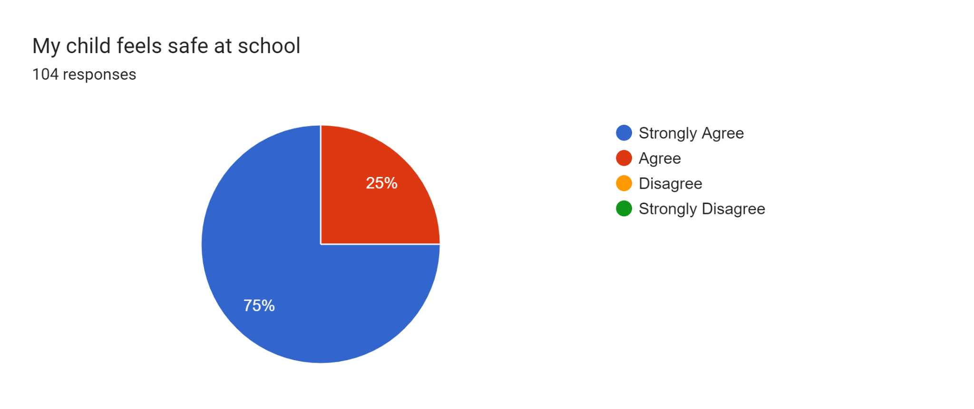
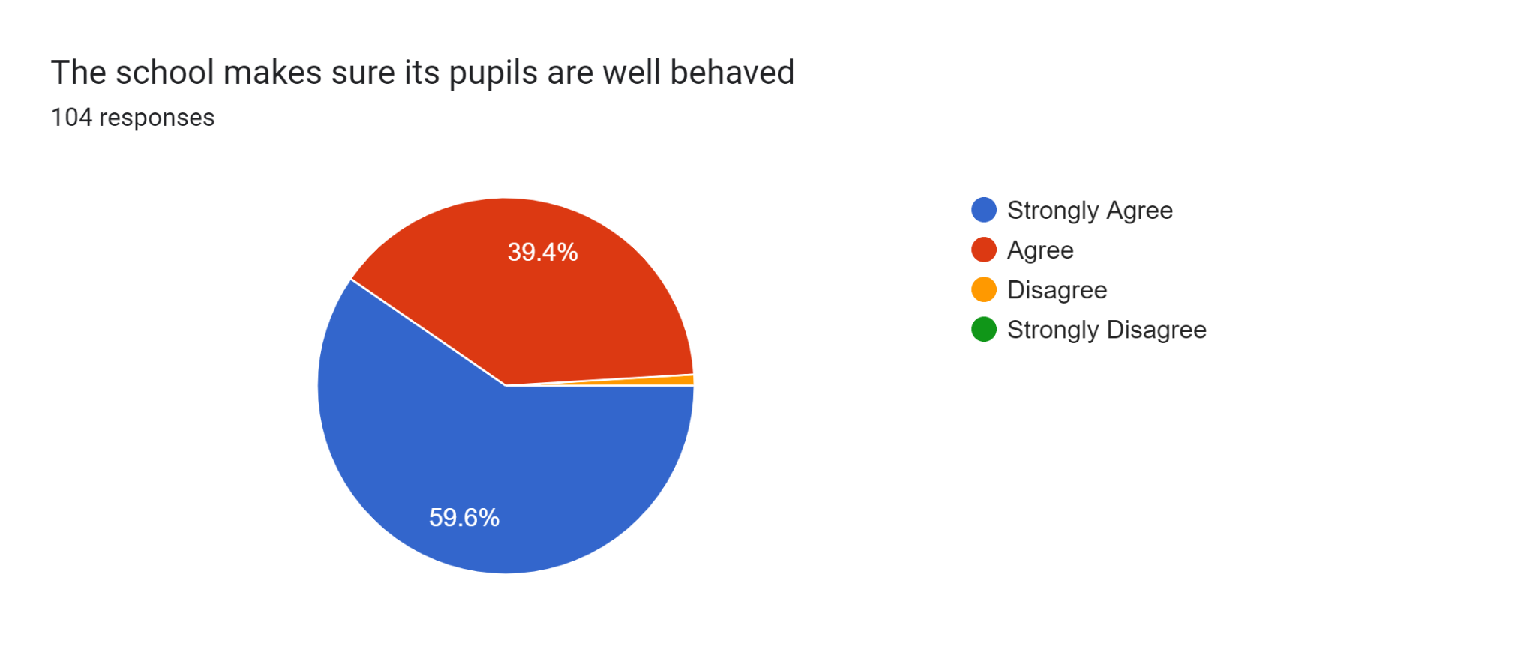
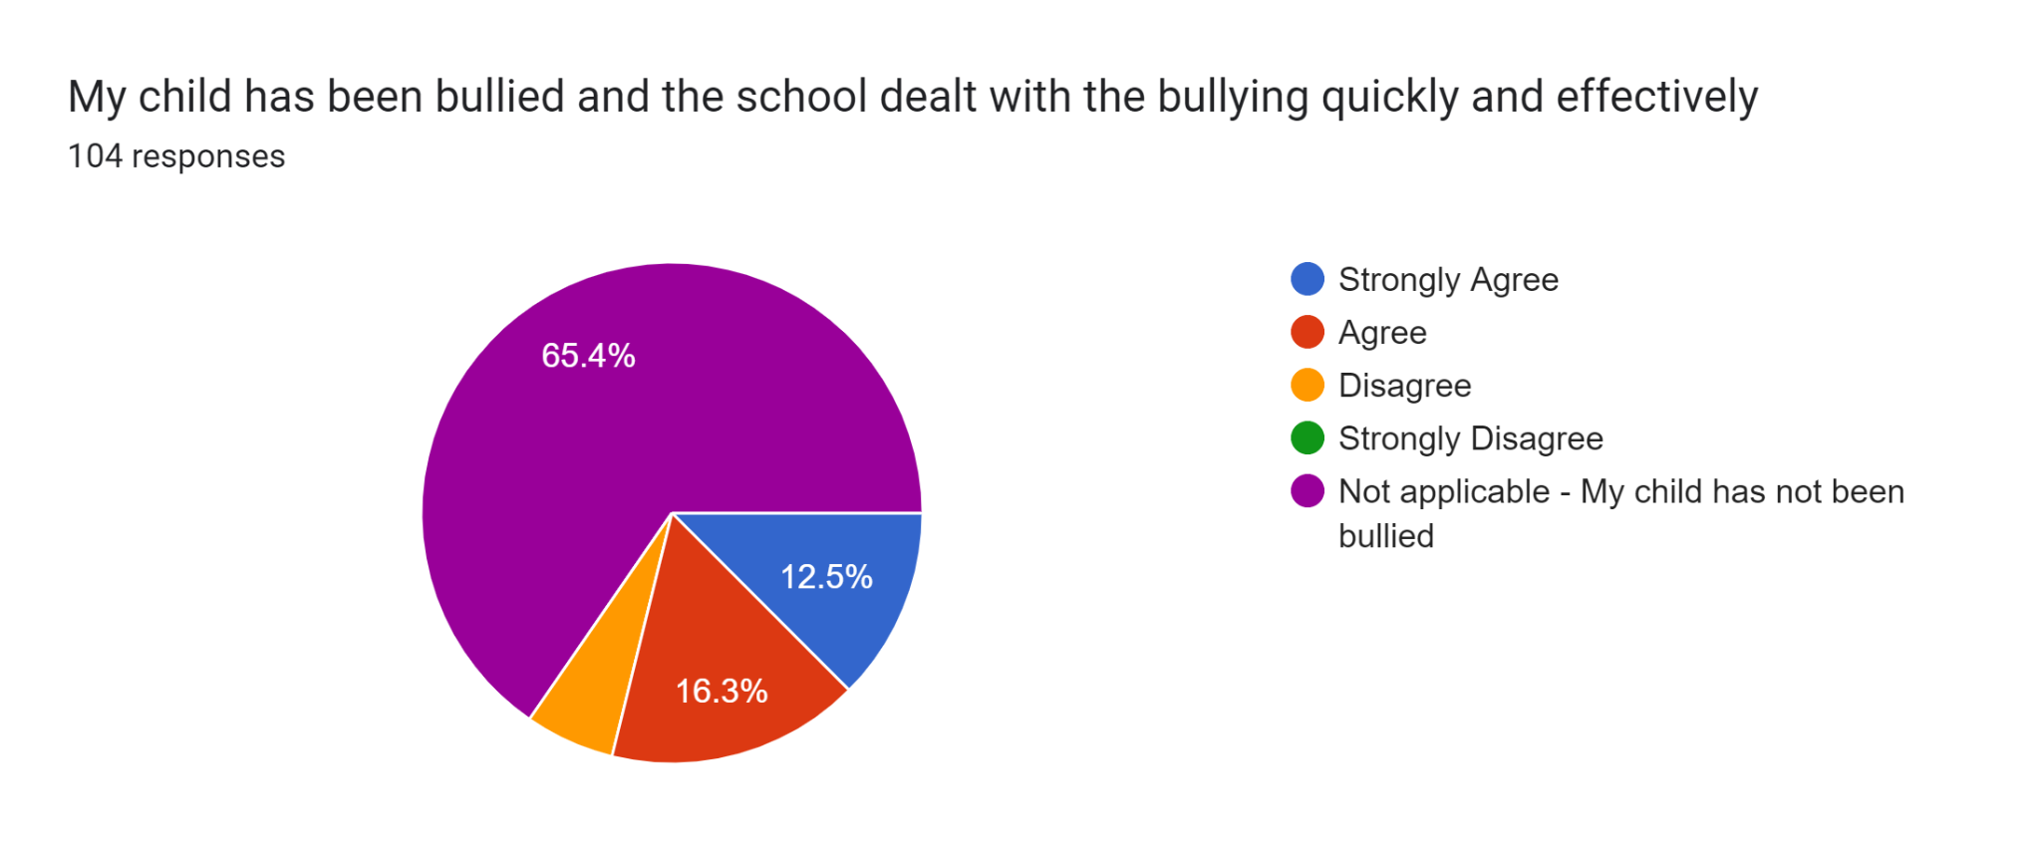
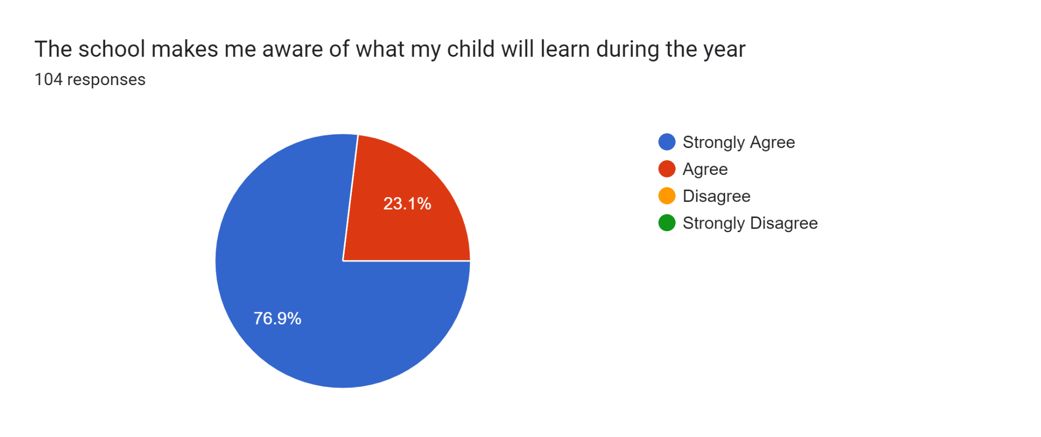
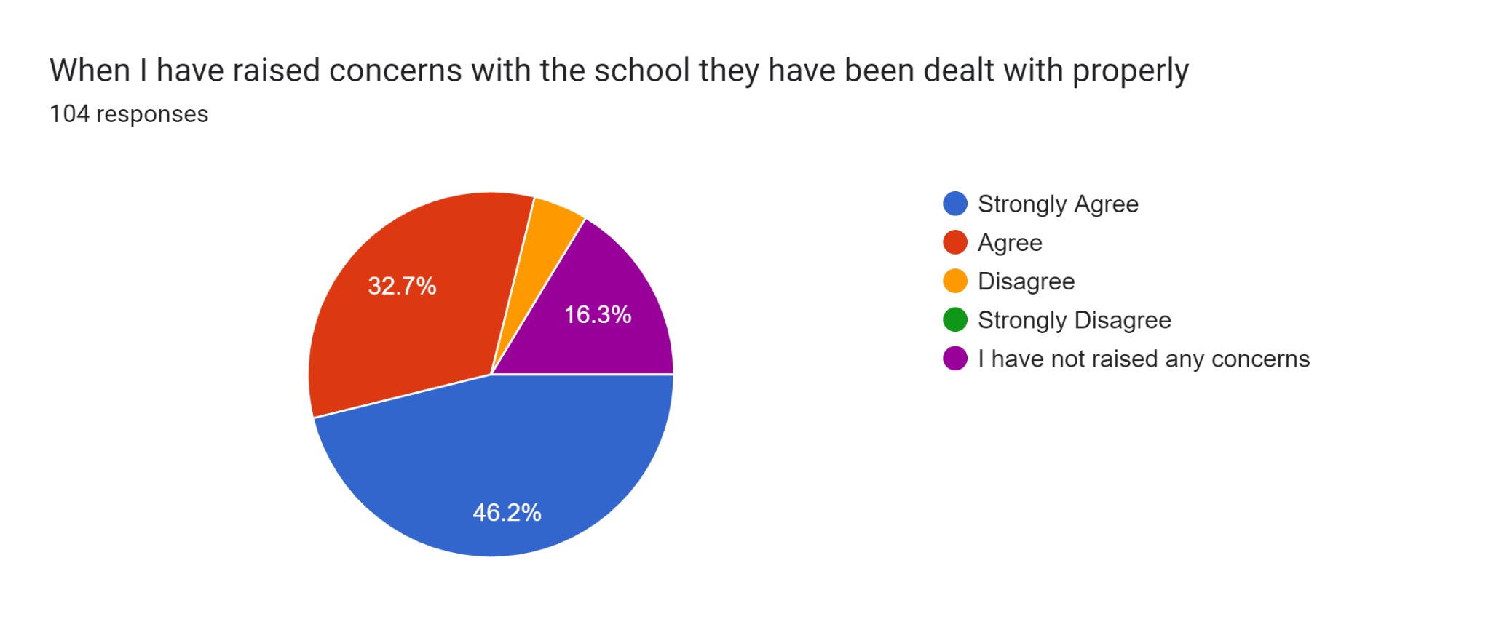
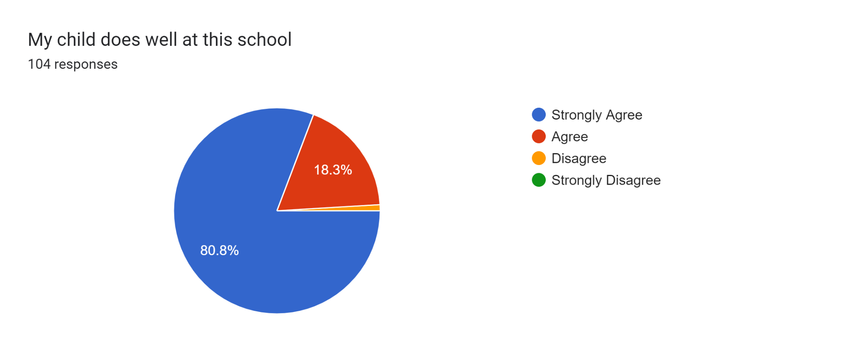
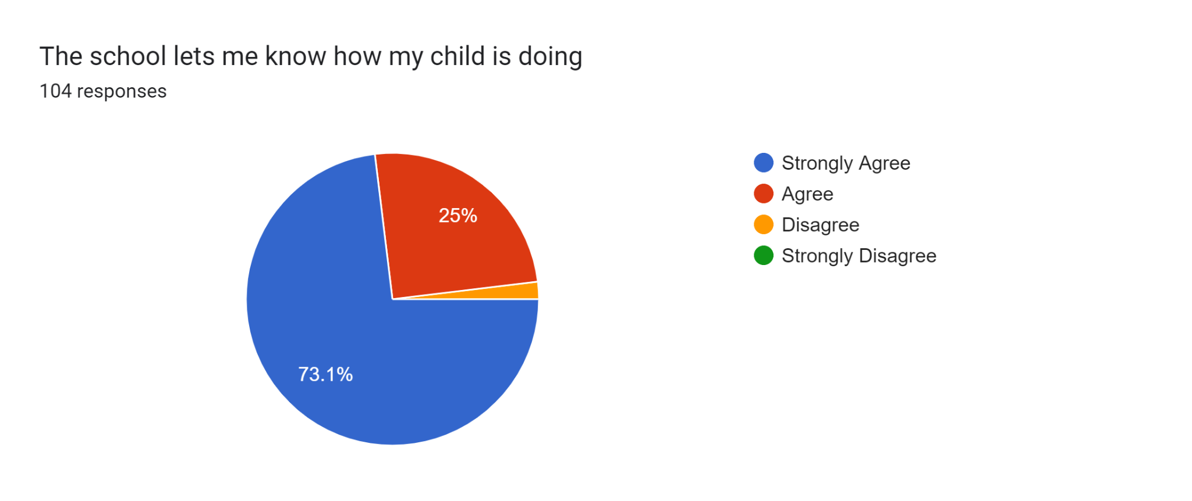
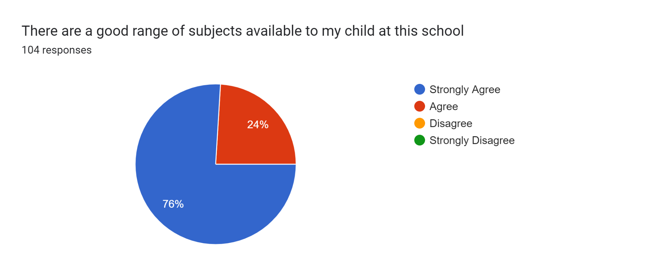
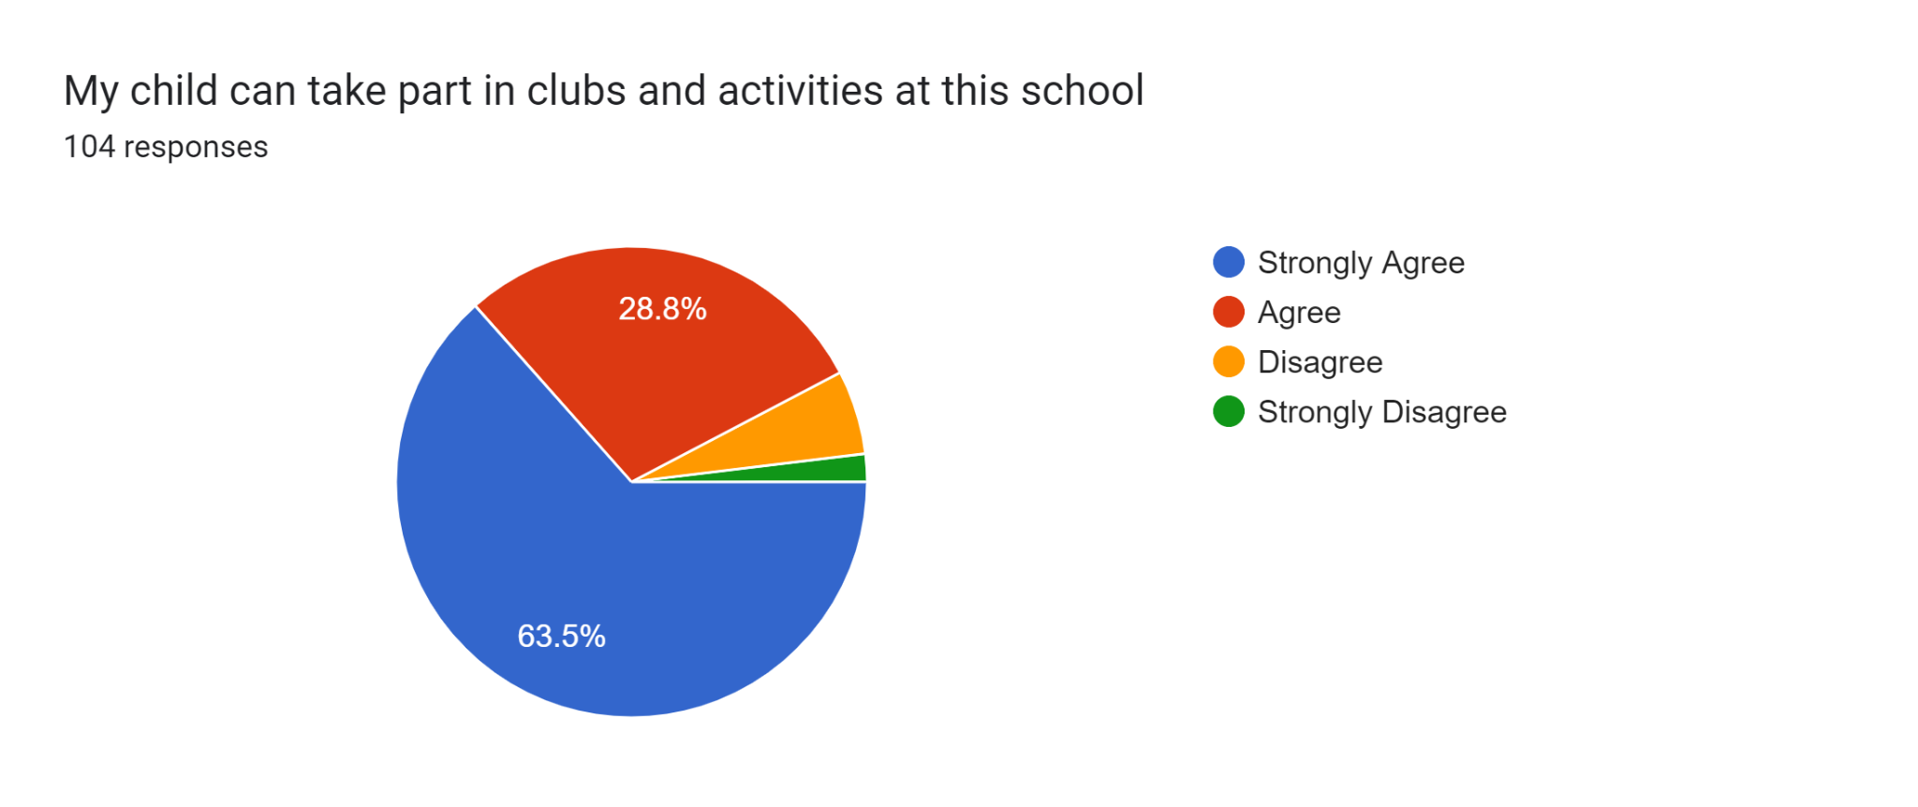
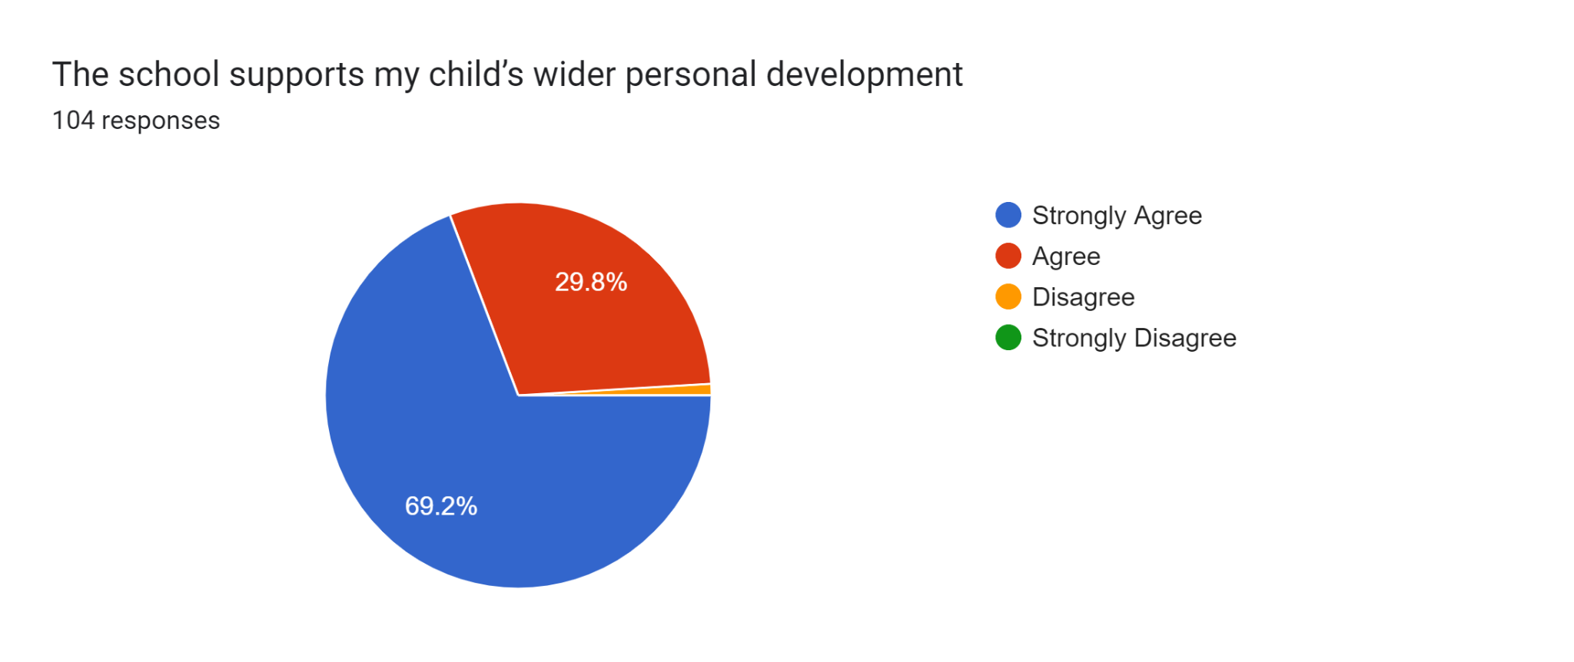
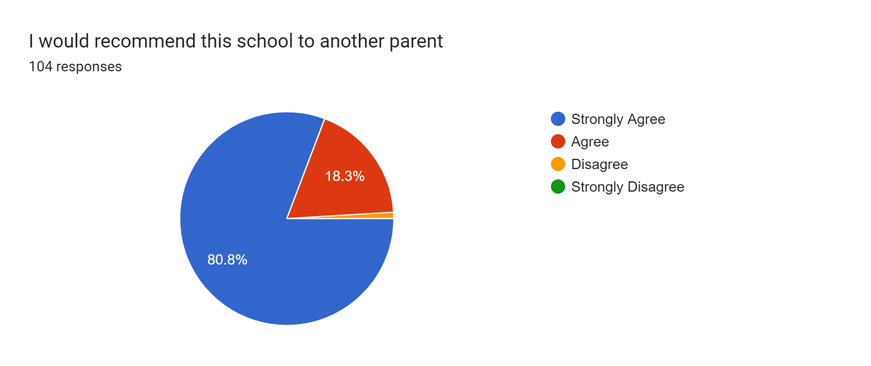
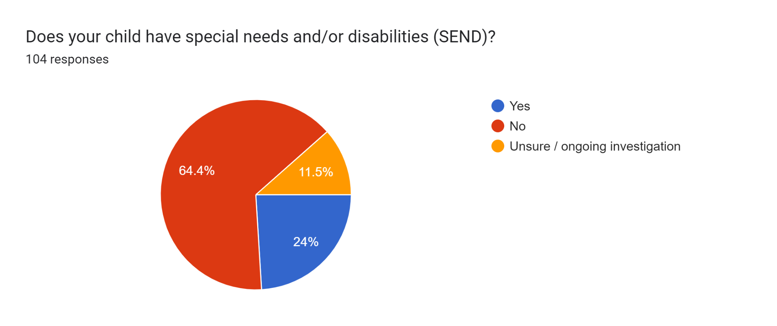
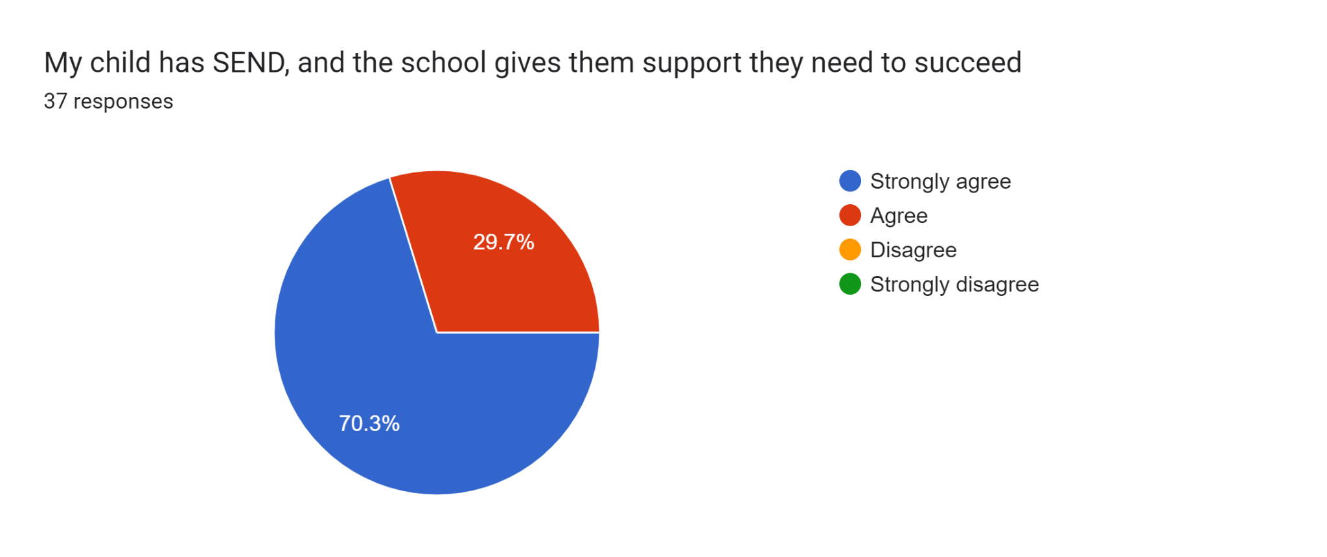
My child is new and has never felt so welcome. Adswood has a sense of community I thought was lost in the 90s
Keep doing great job
Amazing school don't change anything
Great school for all children
No
Miss Hulmes and her team are amazing and my child in reception loves the class and all the great activities that are involved. Thank you
Had good help for my child in the last 3yrs she has come on leaps and bounds .very proud of her lovely school.
My child has thrived since starting this school. He likes to get ready now for school. He talks about school positively all the time and gets excited
All staff at Adswood primary school work very hard to ensure pupils are thriving and striving to reach their full potential.

