Overview of Coverage: PSHE
EYFS | Children’s personal, social and emotional development (PSED) is crucial for children to lead healthy and happy lives, and is fundamental to their cognitive development. Underpinning their personal development are the important attachments that shape their social world. Strong, warm and supportive relationships with adults enable children to learn how to understand their own feelings and those of others. Children should be supported to manage emotions, develop a positive sense of self, set themselves simple goals, have confidence in their own abilities, to persist and wait for what they want and direct attention as necessary. Through adult modelling and guidance, they will learn how to look after their bodies, including healthy eating, and manage personal needs independently. Through supported interaction with other children, they learn how to make good friendships, co-operate and resolve conflicts peaceably. These attributes will provide a secure platform from which children can achieve at school and in later life.  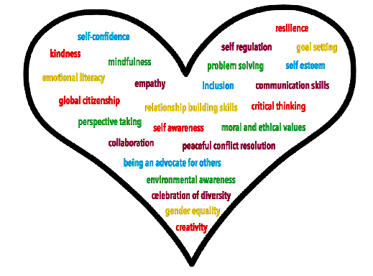  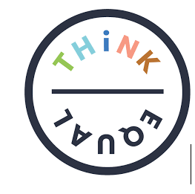  In EYFS we follow the Think Equal Programme, a curriculum-based programme that supports social and emotional development in the early years. It is rooted in mental health and social justice and aims to build a strong foundation for individual and societal progress. The 30-week programme is fully aligned with the early years foundation stage (EYFS) curriculum and teaches 25 skills and competencies to help children through their Early Childhood Education.  Think Equal helps our children to:  - Manage their own emotions and impulsive behaviours  - Build their confidence and self-esteem  - Have empathy and show consideration for others  - Solve problems effectively and learn to resolve conflicts peacefully  - Build critical thinking skills and make responsible decisions  - Maintain healthy relationships and learn to collaborate  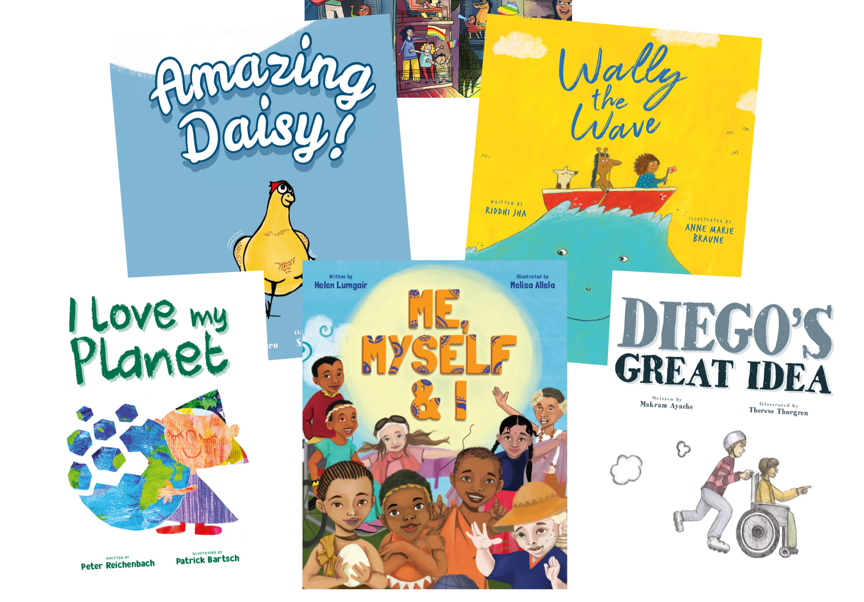  Designed by global experts in the fields of education, human rights, neuroscience and psychology, the Think Equal programme is evidence-based, holistic, easy to use and impactful. It offers a narrative based approach and is delivered flexibly through a collection of picture books.
 | Autumn 1  Living in the wider world  (Rights and responsibilities, Environment, Money). | Autumn 2  Living in the wider world  (Rights and responsibilities, Environment, Money). | Spring 1  Relationships  (Feelings and emotions, Healthy Relationships, Differences). | Spring 2  Relationships  (Feelings and emotions, Healthy Relationships, Differences). | Summer 1  Health and Wellbeing  (Keeping safe, Healthy Lifestyles, Growing and changes). | Summer 2  Health and Wellbeing  (Keeping safe, Healthy Lifestyles, Growing and changes).
Year 1 | Class Expectations/ Group Expectations - - Link to British Values (The Rule of Law/Democracy)  - Identify why rules are important.  - What do we have rules in school for?  Everyone is Unique - Link to British Values (Individual Liberty)  - How are we the same?  - How are we different?  - How do we identify these differences?  Looking after our School - Link with Year 2  - What can we do to keep our school clean and tidy?  - What do we see on a daily basis that show us that we don’t always look after our environment?  E-Safety  - Going Places Safely: Pupils learn that they can go to exciting places online, but they need to follow certain rules to remain safe  Using Digi-Duck story book.  https://digital-literacy.org.uk/curriculum-overview/fs-year1/fs-year1-sol-(1).aspx/ | Looking after the gardens and environment  - What can we do to keep our school clean and tidy?  - What do we see on a daily basis that show us that we don’t always look after our environment  Where does money come from?  - How do we earn money?  - Where does money come from?  Spending and saving  - How can we keep our money safe?  - When is it okay to spend our money?  - What things could we save for?  E-Safety  - ABC Searching:  Pupils search for pictures online by clicking on letters of the alphabet. They learn that directory sites with alphabetical listings offer one way to find things on the Internet  Using SWGfL - Swiggle (Education search engine and resource site for children)  https://digital-literacy.org.uk/curriculum-overview/fs-year1/fs-year1-sol-(1).aspx/ | Sharing how I feel  - How to recognise how I am feeling - Introduce Scaling. I am feeling a (1-10) and developing emotional literacy.  - What should I do when I am feeling…?  Recognising feelings in myself and others  - Who should I talk to if I am feeling..?  - How to recognise how others are feeling.  Special people in my life  - that families are important for children growing up because they can give love, security and stability.  - Identify special people in our lives and how they specifically help us.  - How can we show them that we are grateful for all they do for us?  E-Safety  - Keep it Private: Pupils learn that many websites ask for information that is private and discuss how to responsibly handle such requests  Using CEOP - Hector’s World (Cartoons and teacher resources)  https://digital-literacy.org.uk/curriculum-overview/fs-year1/fs-year1-sol-(1).aspx/ | Secrets and Keeping Safe  - Not keeping secrets that make us feel uncomfortable  - Who can we talk to if we are feeling worried?  - • about the concept of privacy and the implications of it for both children and adults; including that it is not always right to keep secrets if they relate to being safe.  Identifying Difference - Link to British Values (Individual Liberty/Mutual Respect/tolerance of others religion and beliefs)  - How are we all different  - Think about gender- what we like/ dislike  - Different families  Respecting DifferenceLink to British Values (Individual Liberty/Mutual Respect/tolerance of others religion and beliefs)  - Identify the difference between us all.  - Recognise the importance of respecting each other, even if we are different.  - That others’ families, either in school or in the wider world, sometimes look different from their family, but that they should respect those differences and know that other children’s families are also characterised by love and care.  E-Safety  - My Creative Work: Pupils are introduced to the concept of having ownership over creative work. They practice putting their name and date on something they produce.  https://digital-literacy.org.uk/curriculum-overview/fs-year1/fs-year1-sol-(1).aspx/ | How to ask for help if I am worried  - Children should identify key adults at home and in school that they could ask to help if they were worried about something/someone.  Keeping safe at home and in school  - Household products, including medicines, can be harmful if not used correctly  - Identify key dangers and how to remain safe.  What helps to keep my body healthy?  - What do our bodies need to remain healthy- physical activity, sleep, rest, healthy food)  - What could happen if we don’t have enough of these things?  E-Safety  - Sending Email:Pupils explore how they can use email to communicate with real people within their schools, families, and communities.  https://digital-literacy.org.uk/curriculum-overview/fs-year1/fs-year1-sol-(1).aspx/ | Hygiene routines  - Why is it important to remain clean and hygienic?  - LINK- School nurse/ washing hands  Recognising what we are good at  - Set simple goals and targets -these could be reviewed on a half termly basis  Change and Loss and how this feels  - What does it mean to lose something?  - How does it make us feel if we have lost something special?  E-Safety  - Recap/revisit.
Year 2 | Getting help from the community-Link to British Values (Rule of law)  - Emergency services- how to get help when needed  - Contact police service/ fire service/ ambulance and see if they will come in to do a talk  Looking after our community  - What can we do to keep our school clean and tidy?  - What do we see on a daily basis that show us that we don’t always look after our environment?  E-Safety  Staying Safe Online:Pupils understand that they should stay safe online by choosing websites that are good for them to visit, and avoid sites that are not appropriate for them.  Using Smartie the penguin.  https://digital-literacy.org.uk/curriculum-overview/year2/year-2-sol-(1).aspx/ | Looking after the garden and our environment  - What can we do to keep our school clean and tidy?  - What do we see on a daily basis that shows us that we don’t always look after our environment?  Keeping track of money  - Why is money important in the world?  - Show children money and get them to think about the different value  - Link with Maths  How to spend money safely  - Show children different methods of payment. What is safe?  - What is dangerous?  Expectations when living in the wider community - - Link to British Values (Mutual respect)  - How do we behave when…  - What do we have a responsibility to look after?  E-Safety:  Follow the Digital Trail:  Pupils learn that the information they put online leaves a digital footprint or “trail.” This trail can be big or small, helpful or hurtful, depending on how they manage it.  https://digital-literacy.org.uk/curriculum-overview/year2/year-2-sol-(1).aspx/ | Identifying different behaviours  - I know how to feel better  - I know that I could feel worse  Feelings can get hurt  - Show children different faces and get them to think about what their emotions are.  Listening to others and playing co-operatively  - Use scenarios that the children have found themselves in already.  - How can they use this to learn how to respond next time?  - • the importance of permission-seeking and giving in relationships with friends, peers and adults.  - CONSENT  E-Safety:  Screen out the Mean:  Pupils learn that children sometimes can act like bullies when they are online. They explore what cyberbullying means and what they can do when they encounter it.  https://digital-literacy.org.uk/curriculum-overview/year2/year-2-sol-(1).aspx/ | Appropriate and inappropriate behaviours- teasing and bullying  - the characteristics of friendships, including mutual respect, truthfulness, trustworthiness, loyalty, kindness, generosity, trust, sharing interests and experiences and support with problems and difficulties.  - that healthy friendships are positive and welcoming towards others, and do not make others feel lonely or excluded.  Identifying differenceLink to British Values (Individual Liberty/Mutual Respect/tolerance of others religion and beliefs)  - How are we different?  - Children to think of differences in their classes  Valuing differenceLink to British Values (Individual Liberty/Mutual Respect/tolerance of others religion and beliefs)  - Using all the information from previous lesson on identifying different- encourage children to celebrate.  E-Safety:  Using Keywords: Pupils understand that keyword searching is an effective way to locate information on the Internet. They learn how to select keywords to produce the best search results.  https://digital-literacy.org.uk/curriculum-overview/year2/year-2-sol-(1).aspx/ | Keeping safe in different situations  - Identify risk in different situations that children are likely to be in during a school day  - How they/we stay safe?  - How do we get help if we need it?  Keeping safe away from home and school  - Identify risk in different situations that children are likely to be in outside of school  - How they we stay safe?  - How do we get help if we need it?  - • how to respond safely and appropriately to adults they may encounter (in all contexts, including online) whom they do not know.  Making Healthy Choices  - Look at nutritional plates  - Think about the importance of fruit and vegetables.  E-Safety:  Sites I Like: Pupils discuss criteria for rating informational websites and apply them to an assigned site. Pupils learn that all websites are not equally good sources of information.  https://digital-literacy.org.uk/curriculum-overview/year2/year-2-sol-(1).aspx/ | Managing feelings and emotions  What do I do if I am feeling…  Setting goals and recognising what we are good at  - What do we want to achieve during year 3?  - How can we make sure that we achieve our goals?  - What happens if we don’t manage to get there?  Naming body parts  (INFORMATION LETTER TO BE SENT TO PARENTS)  Children introduced to scientific body parts  E-Safety:  Recap/revisit.
Year 3 | Identify what is meant by ‘a moral citizen’ - - Link to British Values (Link to democracy/mutual respect/individual/Rule of Law)  - Opportunity to debate different opinions.  - Explore language- what is morality? What is a citizen?  How can you be involved in the community?  - What opportunities are there for me to be a moral citizen?  - Think about Adswood community in particular  - that in school and in wider society they can expect to be treated with respect by others, and that in turn they should show due respect to others, including those in positions of authority.  What is an enterprise? What does it mean?  - Project Opportunity?  - Link to summer fair?  E-Safety  Powerful Passwords:  Pupils explore reasons why people use passwords, learn the benefits of using passwords, and discover strategies for creating and keeping strong, secure passwords.  https://digital-literacy.org.uk/curriculum-overview/year3/year-3-sol-(1).aspx/ | Developing skills in enterprise  - Project Opportunity?  - Link to summer fair?  How can we look after our planet?  - What is our responsibility when looking after the planet?  - How can we make sure that we look after our environment?  What effects are we having on our planet?  - Show children clips from blue planet/ planet earth  - Recognise the impact of the way that we live our live  - Find out more online about environmental issues.  E-Safety - Link to British Values (tolerate those of different faiths and beliefs)  My Online Community: Pupils explore the concept that people can connect with one another through the Internet. They understand how the ability for people to communicate online can unite a community.  https://digital-literacy.org.uk/curriculum-overview/year3/year-3-sol-(1).aspx/ | Recognising feelings in others - - Link to British Values (Tolerance of difference beliefs)  - How can I appropriately respond when someone is clearly feeling a different way to me  - that most friendships have ups and downs, and that these can  often be worked through so that the friendship is repaired or even  strengthened, and that resorting to violence is never right.  - Link to work with restorative approaches  Responding appropriately to people’s feelings  - How to recognise how people are feeling  - When it is appropriate to respond  - How to respond when...  Describe positive relationships and friendships  - that stable, caring relationships, which may be of different types, are at the heart of happy families, and are important for children’s security as they grow up.  - Encourage the children to recognise when a relationship is healthy and unhealthy  - Focus on bullying in particular - CONSENT AND PHYSICAL CONTACT  E-Safety  Things for Sale: Pupils examine product websites and understand that the purpose of the site is to encourage buying the product. Pupils learn methods used to promote products on these sites.  https://digital-literacy.org.uk/curriculum-overview/year3/year-3-sol-(1).aspx/ | How actions affect ourselves and othersLink to British Values (Mutual Respect/tolerance of others religion and beliefs)  - the conventions of courtesy and manners. Consent.  - Treating all children with respect in school  - Recognising and appreciating our different qualities  Recognising what bullying is  - What is the difference between bullying and an isolated incident  - about different types of bullying (including cyberbullying), the impact of bullying.  How to respond when you think that someone is being bullied  - responsibilities of bystanders (primarily reporting bullying to an adult) and how to get help.  - Link to charity work: bullyinguk / childline  - Recognise key adults who can help.  E-Safety  Show Respect Online: Pupils explore the similarities and differences between in person and online communications, and then learn how to write clear and respectful messages.  https://digital-literacy.org.uk/curriculum-overview/year3/year-3-sol-(1).aspx/ | What makes a balanced diet?  - Identify the impact of a healthy diet on the body (link with Science)  Opportunities for making our own choices Link to British Values (Individual Liberty)  - how important friendships are in making us feel happy and secure, and how people choose and make friends.  - How can others influence our choice and how do we make sure we are making the right choices to be healthy and active?  - (Science)  Who helps us feel safe and healthy?  - Identify key people in our lives who support our development.  - how to recognise if family relationships are making them feel unhappy or unsafe, and how to seek help or advice from others if needed.  E-Safety  Writing Good Emails:Pupils learn how to communicate effectively by email, taking into account the purpose and audience of their message, and the tone they want to convey.  https://digital-literacy.org.uk/curriculum-overview/year3/year-3-sol-(1).aspx/ | How to respond if someone needs help  - Show children different scenarios and encourage them to think about how they would access help - Discuss emergency services/practice basic first aid.  Setting goals and recognising what we are good at  - What do we want to achieve during our time in year 3?  - How can we make sure that we are successful?  Describe feelings- conflicting feelings and how to manage them  - the importance of self-respect and how this links to their own happiness.  - When I am…, I feel…  - How can I manage how I am feeling  - (Link with Learning mentor work)  E-Safety  Recap/revisit
Year 4 | Recognise and manage risk in our local area  - What could happen in our local area that could be unsafe?  Recognise and manage risk in the world  - As we get older, what risks do we see in the world outside of school?  - What can we do to ensure that we manage the risk and stay safe?  - What do we do when we recognise this?  How to effectively manage money  - Saving and budgeting  E-Safety - - Link to British Values (Mutual respect/Rule of Law)  Rings of Responsibility:Pupils explore what it means to be responsible to and respectful of their offline and online communities as a way to learn how to be good digital citizens  https://digital-literacy.org.uk/curriculum-overview/year4/year-4-sol-(1).aspx/ | What are loans and what is interest? Link to British Values (Rule of law)  - When would we need to ask for a loan?  - Understand that loans often come with interest  - Is it a good idea to have lots of loans?  What does it mean to be sustainable?  - How can we live sustainably?  - Link to sustainable housing project  How can we be sustainable?  - What could we do in school to be more sustainable?  - What is the importance of it?  E-Safety  Private and Personal Information: How can you protect yourself from online identity theft? Pupils think critically about the information they share online.  https://digital-literacy.org.uk/curriculum-overview/year4/year-4-sol-(1).aspx/ | When is it appropriate to keep a secret?  - Encourage children to talk about times when they have been asked to keep a secret  - How did it make them feel?  Listening to other’s point of view - Link to British Values (Tolerance of beliefs)  - Go through the concept of Restorative Approach  - Identify the importance of listening to each other  Acceptable and Unacceptable physical contact  - Think about it in school.  - Children to appreciate the need to respect personal space  - that each person’s body belongs to them, and the differences between appropriate and inappropriate or unsafe physical, and other, contact.  E-Safety:  The Power of Words: Pupils consider that they may get online messages from other kids that can make them feel angry, hurt, sad, or fearful. Pupils identify actions that will make them Upstanders in the face of cyberbullying.  https://digital-literacy.org.uk/curriculum-overview/year4/year-4-sol-(1).aspx/ | Negotiation and Compromise- seeing all views and opinions  - Looking at how other people see things- the beach ball activity where children all see the different perspectives  Recognising what children are good at and that we are all good at different things Link to British Values (Individual Liberty/Mutual Respect)  - Activity: Children to write down what they are good at on their backs  Raising concern and challenging something when you don’t believe that it is right  - Encourage children to have the confidence to do the right thing.  E-Safety:  The Key to Keywords: Pupils learn strategies to increase the accuracy of their keyword searches and make inferences about the effectiveness of the strategies.  https://digital-literacy.org.uk/curriculum-overview/year4/year-4-sol-(1).aspx/ | What makes a balanced lifestyle?  - Children to think about an active lifestyle  - Link to sporting events and what the children can get involved in throughout the year  Drugs that are common to our everyday life  - Introduce children to the concept that drugs are not always negative and can help us to feel better  How to stay safe in our local area  - What dangers are there outside of school?  - How can we ensure that we stay safe?  E-Safety:  Whose is it,Anyway? Pupils learn that copying the work of others and presenting it as one’s own is called plagiarism. They also learn about when and how it's ok to use the work of others. | How to stay safe online  - Follow children’s interests at that minute (e.g. Fortnite)  - Introduce the concept that not everything is as it seems on the internet and they need to be aware of dangers that could be around  Changes at Puberty *Boys and Girls*  - Follow SRE guidelines for teaching puberty. SRE letter to be sent.  - Introduce hormones and body change  - Prepare for year 5 puberty  Changes that happen in life and feelings that are associated with change  - When this happens… I feel like…  E-Safety:  Recap and revisit.
Year 5 | Rules and Laws- Link to British Values (Rule of law)  - What is meant by a rule?  - What is a law?  - What are our rights and responsibilities as moral citizens?  Anti-social behaviourLink to British Values (Rule of law)  - What is anti-social behaviour?  - What is the problem with anti-social behaviour?  The Importance of finance in our lives  - Saving and budgeting  - What do we use money for?  - How can we make sure that we invest sensibly?  E-Safety:  Strong Passwords: Pupils learn how to create secure passwords in order to protect their private information and accounts online.  https://digital-literacy.org.uk/curriculum-overview/year5/year-5-sol-(1).aspx/ | Looking after money- debt management  - When we have money- what do we do to protect it?  How are our actions affecting the oceans?  - Explore Blue Planet and look at the impact that our lifestyle has on marine life  - What will happen if this continues?  How are our actions affecting the climate?  Global Warming  - Look at planet Earth- children to explore the impact of our lifestyle on the planet  - What will the consequences be if this continues?  E-Safety:- Link to British Values (Mutual respect/tolerance different faiths and beliefs).  Digital Citizenship Pledge Pupils work together to outline common expectations in order to build a strong digital citizenship community.  https://digital-literacy.org.uk/curriculum-overview/year5/year-5-sol-(1).aspx/ | How to recognise how someone is feeling  - How do you recognise how someone is feeling  - Link to restorative approaches  Responding when someone feels…  - What do you do when someone is feeling?  Listening to others and learning from others - Link to British Values (Tolerance of others beliefs)  - What can we offer each other?  - What can we learn from each other?  - What are we good at?  E-Safety:  You’ve Won a Prize: Pupils learn what spam is, the forms it takes, and then identify strategies for dealing with it.  https://digital-literacy.org.uk/curriculum-overview/year5/year-5-sol-(1).aspx/ | Negotiation and Compromise- seeing all views and opinions  - Looking at how other people see things- the beach ball activity where children all see the different perspectives  Recognising what children are good at and that we are all good at different things - Link to British Values (Individual Liberty/Mutual respect/Tolerance of others religions and beliefs)  - Activity: Children to write down what they are good at on their backs and then each other.  Raising concern and challenging something when you don’t believe that it is right  - how to recognise and report feelings of being unsafe or feeling bad about any adult.  - how to report concerns or abuse, and the vocabulary and confidence needed to do so.  - Encourage children to have the confidence to do the right thing. Build on moral citizenship- year 4  E-Safety:  How to Cite a Site  Pupils reflect on the  importance of citing all  sources when they do  research. They then  learn how to write  bibliographical citations  for online sources.  https://digital-literacy.org.uk/curriculum-overview/year5/year-5-sol-(1).aspx/ | What positively and negatively affects health and wellbeing?  - The impact of social media on children’s health and wellbeing  Making informed choices- benefits of a healthy lifestyle and balanced diet  How to recognise early signs of physical illness, such as weight loss or unexplained changes to the body  · About safe/unsafe exposure to the sun, and how to reduce the risk of sun damage, including skin cancer  Strategies for managing personal safety/wellbeing.  How to keep safe when children are outside of school. including  how to recognise early signs of physical illness, such as weight loss or unexplained changes to the body  · About safe/unsafe exposure to the sun, and how to reduce the risk of sun damage, including skin cancer  E-Safety:  Picture Perfect: Pupils learn how photos can be altered digitally. They will consider the creative upsides of photo alteration, as well as its power to distort our perceptions of beauty and health.  https://digital-literacy.org.uk/curriculum-overview/year5/year-5-sol-(1).aspx/ | How to stay safe online  - Link to ICT  - How do we stay safe online?  Personal Hygiene  - Children to think about their changing body  - What could happen with their personal hygiene  - Video: Oh no! BO.  Changes at Puberty *Boys and Girls*  Build on from Year 4- Periods/ changing body parts  - SRE letter to be sent  - Boys to learn about girls changes and vice versa  - Children to be given the opportunity to ask questions  Families and people who care for us:  the characteristics of healthy family life, commitment to each other, including in times of difficulty, protection and care for children and other family members, the importance of spending time together and sharing each other’s lives.  To understand that marriage represents a formal and legally recognised commitment of two people to each other which is intended to be lifelong.  E-Safety:  Recap/Revisit
Year 6 | The rights of a child- cultural practice and British Law - Link to British Values  - Link to British values- What are their rights as a child?  - What could change these?  Being critical of what is in the media- what children pass on to others  - Introduce the concept of fake news- What can children believe?  KS2 Enterprise project  - Grow a pound  E-Safety:  Talking Safely Online:Pupils learn that the Internet is a great place to develop rewarding relationships. But they also learn not to reveal private information to a person they know only online.  that people sometimes behave differently online, including by pretending to be someone they are not.  https://digital-literacy.org.uk/curriculum-overview/year6/year-6-sol-(1).aspx/ | How resources are allocated to the world Link to British Values (Democracy).  - Identify fair trade  - How are the worlds resources allocated to countries?  Difference between fair trade. How does it affect others?  - Saving and budgeting  - What is the impact of buying fair trade?  E-Safety:  Super Digital Citizen Pupils explore SpiderMan's motto, "with great power comes great responsibility" through the lens of digital citizenship. They create comic strips show a digital superhero who witnesses an act of poor digital citizenship, and then helps resolve it.  https://digital-literacy.org.uk/curriculum-overview/year6/year-6-sol-(1).aspx/ | Who can you trust?  - Who can you trust and not trust?  - What do you expect from people?  How to make new friends  - Preparing for high school  - What should you look for in a new friend?  Recognising when relationships are unhealthy  - What describes an unhealthy friendship?  - How would you expect to feel?  E-Safety:  Privacy Rules Pupils learn that children’s websites must protect their private information. They learn to identify these secure sites by looking for their privacy policies and privacy seals of approval.  https://digital-literacy.org.uk/curriculum-overview/year6/year-6-sol-(1).aspx/ | Personal boundaries and the right to privacy - Link to British Values (Individual Liberty)  - The importance of protecting peoples personal space  What makes people the same? What makes people different? Link to British Values (Individual Liberty/Mutual Respect/tolerance of others religion and beliefs)  - the importance of respecting others, even when they are very different from them (for example, physically, in character, personality or backgrounds), or make different choices or have different preferences or beliefs.  - Identifying difference and celebrating it  - How can we make everyone feel comfortable with who they are?  Recognising and challenging stereotypes Link to British Values (Democracy)  - what a stereotype is, and how stereotypes can be unfair, negative or destructive.  - What can we do to challenge stereotypes?  E-Safety  What’s Cyberbullying? Pupils explore how it feels to be cyberbullied, how cyberbullying is similar to or different than in-person bullying, and learn strategies for handling cyberbullying when it arises.  https://digital-literacy.org.uk/curriculum-overview/year6/year-6-sol-(1).aspx/ | Risk and effects of drugs Link to British Values (Democracy)  - What are the positive and negative effects of taking drugs?  Images in the media- how does this affect our wellbeing?  - How do the media distort the truth?  - Obsession over social media attention and ‘likes’ ‘dislikes’  Resisting pressure- how to protect our body and speak out when something is wrong  - how to recognise who to trust and who not to trust, how to judge when a friendship is making them feel unhappy or uncomfortable, managing conflict, how to manage these situations and how to seek help or advice from others, if needed.  E-Safety:  Selling Stereotypes :  Pupils explore how the media can play a powerful role in shaping our ideas about girls and boys. They practice identifying messages about gender roles in two online activity zones for children.  https://digital-literacy.org.uk/curriculum-overview/year6/year-6-sol-(1).aspx/ | Changes at Puberty *Boys and Girls*  - Build on from Year 5- Periods/ changing body parts  Human Reproduction  - Betty Bus resources  - Recognising how babies are made  - The process that an embryo develops  - SRE LETTER TO BE SENT HOME  - Understand that sexual intercourse can lead to conception and that is how babies are usually made. Also understand that sometimes people need IVF to help them have a baby.  - Describe how a baby develops from conception through the nine months of pregnancy, and how it is born.  E-Safety:  Recap/revisit.
Key Vocab-ulary | Changes, life cycle, baby, adulthood, mature, male, female, penis, vagina, vulva, anus, change, feelings, anxious, worried, excited | Change, fully grown, respect, appearance, timeline, adult, teenager, responsibilities, freedom, penis, vagina, vulva, testicles, public, private, acceptable, unacceptable, comfortable, uncomfortable. | Birth, changes, uterus, womb, nutrients, service, affection, change, puberty, control, sperm, ovaries, stereotypes, risks, excited, nervous, anxious | Personal, unique, characteristics, penis, vagina, vulva, testicles, public, private, puberty, menstruation, periods, control | Self-image, body image, perception, characteristics, affirmation, puberty, vulva, womb | Self-image, self-esteem, opportunities, freedom, pregnancy,menstruation, tampons, sanitary towels, embryo, cervix, womb, midwife, placenta, umbilical cord, placenta, attraction, relationship, sexting, transition, journey, worries.

