Adswood Primary School Newsletter

Newsletter April 2024
Dear Parents/Carers,

Welcome back ! We hope you have had a wonderful Easter break.
Welcome to all our new nursery starters and their families.
Show Racism the Red Card
All our staff completed the training today during our Inset day. Learning from these sessions will feed into our school curriculum plans and children will be learning about all of us being unique over the coming weeks in school.
Seesaw App
The Seesaw app is used to communicate and engage families with your child’s learning in school and keep you posted of any events coming up in the school diary. I am sure you would agree that the communication tool is fantastic. We will continue to use seesaw as our main source of communication with you. If you wish for any paper copies of anything that is sent on the app, please speak to the school office and we can provide them for you.
Attendance and Punctuality
We are working hard in school to encourage children to be attendance ‘HEROs’ every day! (Here, Every day, Ready to learn, On time). We understand that children will pick up illness and encourage you to contact the school office in the case of any absence this allows the correct code to be added to the register.
Please ensure children are here on time each day. The school gate opens from 8.40am-8.50am and registers taken at 8.55am. We are currently well below the national average (95%) for our school attendance which is currently 92%. Let’s work hard to improve this together.
Year 6 Residential to Kingswood ! (book for next year!)
A memorable residential for our Year 6 classes! Three days packed full of activities– they were exhausted on return to school! We have booked for next year for any child that wishes to attend.
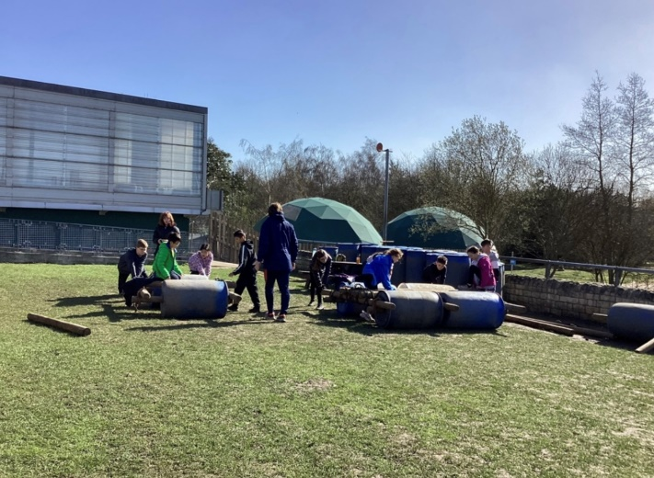
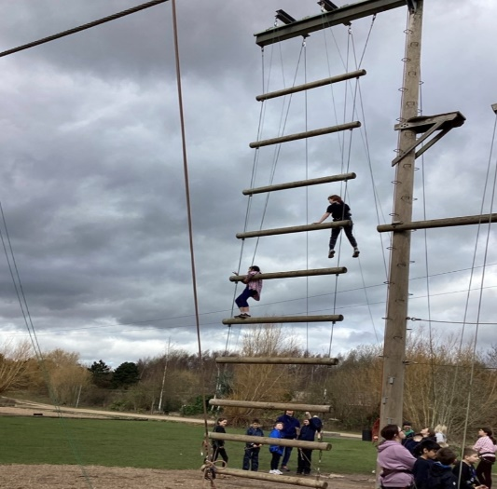

Visits, Visitors and Enrichment (VVE)
Classes have attended workshops or trips this half term from Science workshops at Cheadle Hulme School to a trip to St Matthews church for the Easter Trail. Can we thank you for your donations to our school trips.
Children’s learning
A wealth of information is found on our school website about the learning that takes place in our school. Please spend time looking at our website to gather information and look at ways you can support your child’s learning at home.
Governors
We have a very active, supportive group of Governors that attend meetings in school every half term to focus on school improvement. The Governors also visit school to observe lessons, deliver lessons, support on trips and discuss improvements across school from budgets to learning. Please find the pen portraits of our Governors in our Governing body section on the website.
Dates coming up…..
- Thursday 18th April – Whole School football assembly and workshops
- World Earth Day – Tuesday 23rd April – whole school assembly delivered by Christians in School
- Tuesday 23rd April - Year 5 trip to Cheadle Hulme School to watch the Little Mermaid show
- Tuesday 23rd April - Year 2 trip to Manchester Airport

Thank you for your continued support.

M Smart and the Adswood Team

