Nursery Curriculum 2025-26
Enjoy, Believe, Achieve


Characteristics of effective learning
Playing and Exploring |  | Active Learning |  | Creating and Thinking Critically
Children will be learning to:  - Realise that their actions have an effect on the world, so they want to keep repeating them.  - Plan and think ahead about how they will explore or play with objects.  - Guide their own thinking and actions by referring to visual aids or by talking to themselves while playing.  - Make independent choices.  - Bring their own interests and fascinations into early years settings. This helps them to develop their learning.  - Respond to new experiences that you bring to their attention. |  | Children will be learning to:  - Participate in routines.  - Begin to predict sequences because they know routines.  - Show goal-directed behaviour.  - Begin to correct their mistakes themselves.  - Keep on trying when things are difficult. |  | Children will be learning to:  - Take part in simple pretend play.  - Sort materials.  - Review their progress as they try to achieve a goal.  - Check how well they are doing. Solve real problems.  - Use pretend play to think beyond the ‘here and now’ and to understand another perspective.  - Know more, so feel confident about coming up with their own ideas.  - Make more links between those ideas. Concentrate on achieving something that’s important to them.  - They are increasingly able to control their attention and ignore distractions.
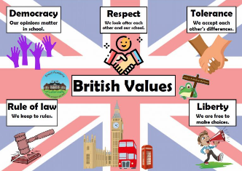

In the Early Years, the fundamental British Values are explored in ways that are meaningful to young children. Fundamental British values are important democratic values. Overall, the goal of these values is to enable people to be part of a democratic society and to help them to look after others around them. The Fundamental British Values are: Democracy The rule of law Individual liberty Mutual respect and tolerance of those of different faiths and beliefs

Autumn 1 | Autumn 2 | Spring 1 | Spring 2 | Summer 1 | Summer 2
Super Duper You | Amazing Autumn | Once Upon A Time | In The Garden | Under The Sea | Down At The Farm
Key texts to support key themes.
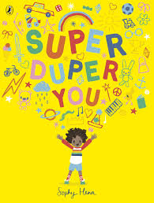  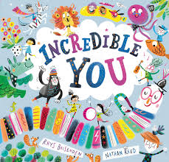  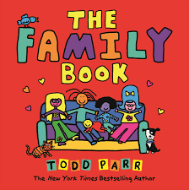  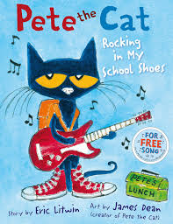  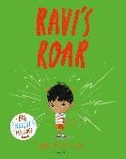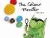 | 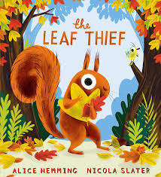  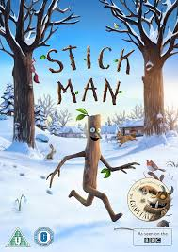  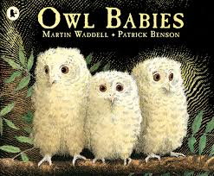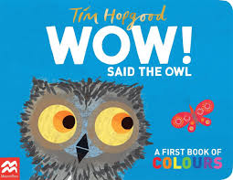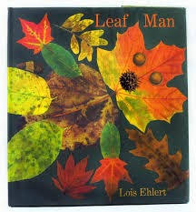 | 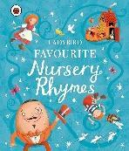  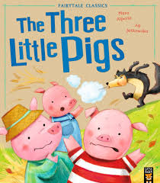  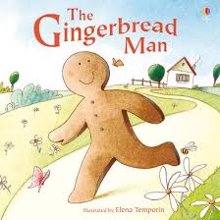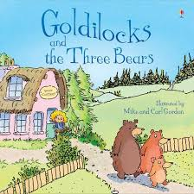  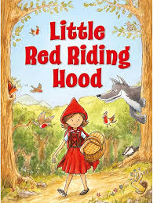 | 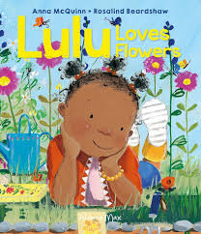  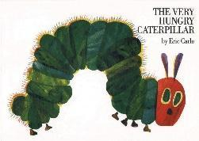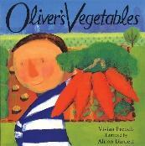  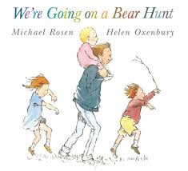  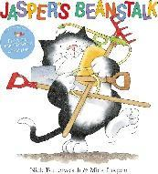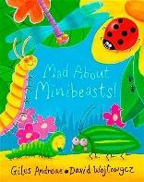 | 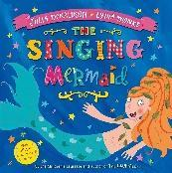  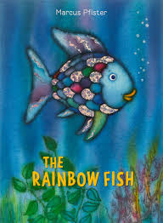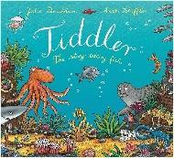  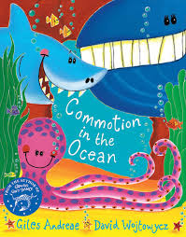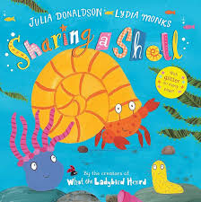 | 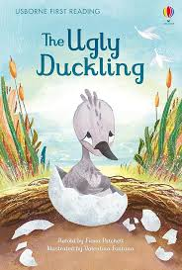  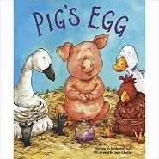  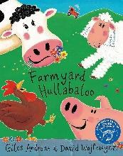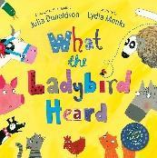  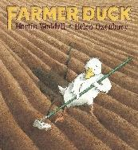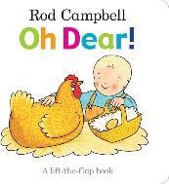  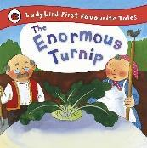
Key songs and number rhymes to support key themes.
If You’re Happy and You Know  It...  I’m a Little Teapot  Bingo  Finger Family | Teddy Bears Picnic  Incy, Wincy, Spider  Twinkle, Twinkle Little Star  Christmas Songs | Teddy Bear, Teddy Bear  Turn Around | Down in the Jungle  5 Little Monkeys  Walking in the jungle... | I Can Sing a Rainbow  Sleeping Bunnies  Mary, Mary Quite  Contrary | 5 Little Speckled Frogs  5 Little Ducks  Row, row, row your boat  One, Two, Three, Four,  Five
Key ‘Concept Cat’ Words and Blanks Level Questioning - Size, Touch, Movement, Order, Time
Long  Short  Tall  Small  Large | Hard  Soft  After  Before  Day  Night | First  Last  Quick | Repeat  Long  Short  Tall  Small  Large | Repeat  Hard  Soft  After  Before  Day  Night | Repeat  First  Last  Quick
Communication and Language
Autumn |  | Spring |  | Summer
Listening, Attention and Understanding  - Listen to simple stories and understand what is happening, with the help of the pictures.  - Enjoy listening to longer stories and begin to remember much of what happens.  - Daily story time.  - Listen to short stories with illustrations / props / sounds.  - Begin to join in text retell with some actions.  - Understand simple questions about ‘who’, ‘what’, and ‘where’.  - Get to know: - one another - new adults - new environment.  - Find body / move different body parts…Wiggle Me into Squiggle  - Where do we live? Understand or act on longer sentences like ‘make teddy jump’ or ‘find your coat’. Follow an instruction that has one part.  - Linked to: self-organisation / daily routine / group time.  - Pay attention to one thing at a time.  -Listen 1:1 to develop independence within daily routine. - Participate in short inputs of daily group time.  Speaking  - Start to say how they are feeling, using words as well as actions.  - Begin to use a wider range of vocabulary.  - Start to develop conversation, often jumping from topic to topic.  - Start a conversation with an adult or a friend.  - Begin to use talk to organise themselves and their play  - Begin to communicate needs with adults.  - Learn new rhyme and begin to develop a repertoire of songs.  - Join in with actions / props  - Fill in some missing words.  - Begin to develop communication, using some awareness of tense. |  | Listening, Attention and Understanding  - Continue to enjoy listening to longer stories and remember much of what happens.  - Daily story time / weekly shared read, small group.  - Begin to pay attention to more than one thing at a time.  - Begin to understand and follow a question or instruction that has two parts.  - Begin to listen to others in a small group.  -Daily group time / small group focus tasks.  - Understand some simple ‘why’ questions.  - Demonstrate understanding by beginning to make comments on what they know/have experienced.  Speaking  - Use a wider range of vocabulary.  - Linked to: – themes - play  - Continue to develop and sing a large repertoire of songs.  - Recite some rhymes.  - Sing as part of a group, using mostly the correct lyrics and pay attention to how songs sound.  - Begin to talk confidently about familiar books.  - Begin to tell longer stories.  -Small group shared read / 1:1 story.  - Start a conversation with an adult or a friend and begin to continue it for many turns.  - Develop shared attention by responding to others thoughts.  - Continue to use talk to organise themselves and their play.  - Begin to build relationships with others.  - Use longer sentences that contain 4/6 words.  - Begin to join sentences with ‘and’.  - Give and receive comment/instruction from others during play.  - Begin to retell a simple past event in correct order.  -What did you do at the weekend?  - Continue to develop communication, using future and past tense (not always correctly). |  | Listening, Attention and Understanding  - Enjoy listening to longer stories (with increased attention) and remember much of what happens.  - Identify beginning, middle and end.  - Pay attention to more than one thing at a time by shifting their attention from one thing to another when needed or given a prompt.  - Understand and follow a two-part instruction.  - Listen to others in a small group.  - Begin to make simple comments on the thoughts or actions of others: - small group work.  - Understand and respond confidently to simple ‘why’ questions.  -Why do you think he/she feels…?  Speaking  - Use a wider range of vocabulary in a range of contexts.  - Linked to: – themes – play – experiences  - Sing a large repertoire of songs.  - Recite many rhymes, as part of a group and independently.  - Regularly engage in group singing.  - Anticipate words and fill in missing phrases correctly.  - Talk about a familiar book, and tell a long story  - Discuss characters, setting, problem, solution.  -Small world / role play.  - Start a conversation with an adult or a friend and continue it for many turns.  - Confidently use talk to organise themselves and their play.  - Establish good relationships and friendships.  - Use sentences joined by other words such as ‘like’ / ‘because’.  - Retell a simple past event in order.  - Develop their communication, begin to use a wider range of tenses (with correct use of most tenses).  - Talk about their experiences confidently.  - Be able to express a point of view and to debate when they disagree with an adult or a friend, using words as well as actions.  - Begin to recognise and establish boundaries. .
Personal, Social and Emotional Development
Children’s personal, social and emotional development (PSED) is crucial for children to lead healthy and happy lives, and is fundamental to their cognitive development. Underpinning their personal development are the important attachments that shape their social world. Strong, warm and supportive relationships with adults enable children to learn how to understand their own feelings and those of others. Children should be supported to manage emotions, develop a positive sense of self, set themselves simple goals, have confidence in their own abilities, to persist and wait for what they want and direct attention as necessary. Through adult modelling and guidance, they will learn how to look after their bodies, including healthy eating, and manage personal needs independently. Through supported interaction with other children, they learn how to make good friendships, co-operate and resolve conflicts peaceably. These attributes will provide a secure platform from which children can achieve at school and in later life.

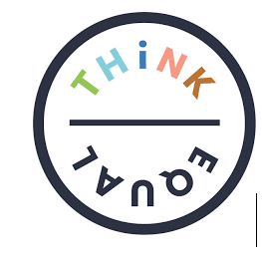
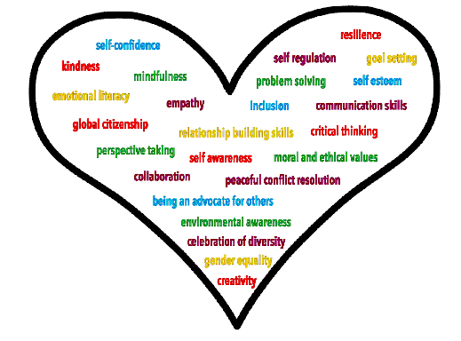
In EYFS we follow the ‘Think Equal’ Programme, a curriculum-based programme that supports social and emotional development in the early years. It is rooted in mental health and social justice and aims to build a strong foundation for individual and societal progress. This programme is fully aligned with the early years foundation stage (EYFS) curriculum and teaches 25 skills and competencies to help children through their Early Childhood Education.
Think Equal helps our children to:
- Manage their own emotions and impulsive behaviours
- Build their confidence and self-esteem
- Have empathy and show consideration for others
- Solve problems effectively and learn to resolve conflicts peacefully
- Build critical thinking skills and make responsible decisions

- Maintain healthy relationships and learn to collaborate

Designed by global experts in the fields of education, human rights, neuroscience and psychology, the ‘Think Equal’ programme is evidence-based, holistic, easy to use and impactful. It offers a narrative based approach and is delivered flexibly through a collection of picture books.
Autumn |  | Spring |  | Summer
- Me, Myself and I.  - Is there anyone like me?  - Amazing Daisy  - How we feel?  - Wally the Wave  - I have a plan  - The Wall  - The tale of Baby Beetroot. |  | - Lara the Yellow Ladybird  - My Voice  - Kitchi’s Moccasins.  - Helping Hands  - Diego’s great plan.  - Head, Heart and hands  - My Amazing Brain |  | - Home  - A time to be noisy.  - I love my planet  - Ananji’s Kite  - Sizwe’s Smile  - My Special hair  - Mum loves me so much/Dad loves me so much.  - Caring Animals
Physical Development
Autumn |  | Spring |  | Summer
Gross Motor Skills  - Continue to enjoy kicking, throwing and catching balls. --Rolling (partner / circle games outdoors)  -Kicking  -Catching a light throw from a short distance with two hands and arms extended  - Continue to development fundamental movement skills of walking, running, balancing.  - Negotiating space with others.  - Begin to adapt speed / direction to avoid obstacles.  - Stand still / stand on one leg.  - Continue to develop climbing skills.  - Use the stairs independently. Go up steps and stairs, or climb up apparatus, using alternate feet.  - Go up / down ramps  - Continue to develop riding climbing skills – scooter / trike / balance bike  - Show an increasing desire to be independent, such as wanting to feed themselves and dress/undress.  - Begin to use large-muscle movements.  - Wave flags and streamers (top to bottom / circle – Wiggle Me into Squiggle)  - Paint and make marks  - Begin to jump with two feet and learn to hop on one foot.  Fine Motor Skills  - Begin to eat independently with a knife and fork.  - Begin to increase independence as they get dressed and undressed.  - Begin to show a preference for a dominant hand.  - Use some one-handed tools and equipment.  - Across provision: - pouring / filling – stirring / mixing – rolling – painting / drawing / mark making.  - Begin to develop a comfortable grip when using pencils / pens. - Support and encourage tripod grip. |  | Gross Motor Skills  - Continue to develop throwing, catching and ball skills  - Continue to develop movement of walking, running  - Continue to develop climbing skills  - Continue to develop balancing skills  - Continue to jump with two feet and learn to hop on one foot  - Continue to develop riding skill.  - Develop moving safely and stopping with control.  - Use large muscle movements.  - Move safely and sensibly in a space with consideration of others.  - Begin to remember some sequences and patterns of movement related to music and rhythm  - Learn some simple dance / action routines to familiar songs  - Use different travelling actions whilst following a path.  - Begin to match developing physical skills to tasks and activities in setting  - Choose the right resource to carry out chosen plan  - Use equipment safely and responsibly.  - Begin to take part in some group team activities  - Work with others co-operatively and play as a group.  - Follow, copy and lead a partner.  - Begin to collaborate with others to manage large items.  - Outdoor construction  Fine Motor Skills  - Show a preference for a dominant hand  - Use a range of one-handed tools and equipment  -Across provision: - pouring / filling – stirring / mixing – rolling – cutting/sticking – painting / drawing / mark making.  - Continue to learn to use a knife and fork.  - Continue to increase independence getting dressed and undressed  - Continue to develop a comfortable grip with good control when holding pens and pencils.  - Model tripod grip. |  | Gross Motor Skills  - Begin to refine throwing, catching and ball skills  - Begin to refine movement of walking, running  - Begin to refine climbing skills  - Begin to refine balancing skills  - Develop balancing and taking weight on different body parts  - Jump with two feet and hop on one foot  - Develop jumping and landing safely  - Develop rocking and rolling  - Begin to refine riding  - Use large muscle movements.  - Copy and create shapes with our bodies  - Remember some sequences and patterns of movement related to music and rhythm.  - Explore different body parts and how they move and remember and repeat actions  - Create movements and adapt and perform the simple dance patterns  - Copy and repeat actions showing confidence and imagination  - Copy and create short sequences by linking actions together  - Match developing physical skills to tasks and activities in setting.  - Express and communicate ideas through movement exploring directions and levels  - Move with control and co-ordination, linking, copying and repeating actions  - Choose the right resource to carry out chosen plan.  - Take part in some group team activities, which they make up themselves or in teams.  - Collaborate with others to manage large items.  - Create shapes whilst on apparatus  Fine Motor Skills  - Use one-handed tools and equipment confidently and independently... scissors, glue sticks, pencils, pens, marker pens.  -Across provision: cutting/sticking – painting / drawing / writing letters.  - Eat independently using a knife and fork  - Be increasingly independent getting dressed and undressed  - Use a comfortable grip with good control when holding pens and pencils. - Tripod grip.
Literacy

Phonics – Read Write Inc

We follow ‘Read Write Inc’ (RWI), which is a systematic synthetic phonics scheme. Following 4 weeks of whole class teaching in Autumn 1, the children are then streamed into smaller ability groups across Reception.
Reading
Autumn |  | Spring |  | Summer
- Phase 1 games  - Nursery Rhymes. |  | - Join in with nursery rhymes and songs, and  show an interest in stories.  - Develop phonological awareness of the initial sounds in words, rhyming, alliteration and syllable clapping.  - Recognise own name  - Hear and say initial sounds in words  - Begin to orally blend cvc words (Fred Talk)  - Sequence and retell familiar fiction and  non-fiction texts.  - Read individual letters (set 1) by saying the  sounds for them, in line with RWI.  - Blend sounds into words, so they can read cvc  - words. |  | - Join in with nursery rhymes and songs, and  show an interest in stories.  - Develop phonological awareness of the initial sounds in words, rhyming, alliteration and syllable clapping.  - Recognise own name  - Hear and say initial sounds in words  - Begin to orally blend cvc words (Fred Talk)  - Sequence and retell familiar fiction and  non-fiction texts.  - Read individual letters (set 1) by saying the  sounds for them, in line with RWI.  - Blend sounds into words, so they can read cvc  - words.
Writing
Autumn |  | Spring |  | Summer
- Add some marks to their drawings, which they give meaning to. For example: “That says daddy.”  - Make marks on picture to stand for their name…write, picture, draw, mark  - Draw circles and lines (horizontal and vertical) … line, across, down, circle, around  - Begin to attempt to write name with some recognisable letters - First letter of name  - To begin to understand that own marks represent meaning - Point to marks  - Talk about made marks  - Label marks... label |  | - Begin to use some print / letter knowledge in writing  - Symbols – lines / circles  - Recognisable letters, ascribe meaning  - Left to right direction/ point to directionality  - Top to bottom directionality  - Begin to engage in purposeful mark marking  - Begin to draw a horizontal / vertical cross  - Attempt to write name, using name card, with some recognisable letters, some correctly formed.  - Attempt to write labels, with some recognisable letters |  | - Use knowledge of print / letter knowledge in writing  - Recognisable letters  - Left to right / top to bottom directionality ⇨ Top to bottom directionality  - Begin to draw a square  - Begin to match some letters to phonemes e.g. m for mummy  - Engage in purposeful early writing  - Write name, from memory, with correct letter formation
,Maths – Mastery in Number & White Rose Maths
Autumn |  | Spring |  | Summer
- Recognise the colour red, blue, and green, purple.  - Recognise matching buttons. Shoes, matching towers, number shapes.  - Matching the same size.  - Matching prints.  - Sorting by size.  - Sorting by colour.  - Sorting by shape.  - Sorting – What do you notice?  - Sorting – Guess my rule.  - Number 1 – Subitising, counting, numeral matching.  - Number 2 – Subitising dice patterns, different patterns.  - Number 2 – counting, linking numeral and amounts.  - Colour AB patterns.  - Fixing a pattern. |  | - Subitising 3  - Counting 3  - Composition of 3  - Recognise triangles.  - Counting 4.  - Numeral 4  - Recognising squares and rectangles.  - Composition of 4.  - Counting 5  - Numeral 5  - Recognise pentagons  - Composition of 5  - Counting 6  - Tall and short  - Long or short  - Mass – balancing scales  - Mass – heavier or lighter.  - Capacity - full/empty, nearly full/empty  - Capacity comparing containers. |  | - Sequencing  - Position – on and under.  - Position – in and out.  - Position – in front or behind.  - Comparing groups – more than, fewer than.  - 2D shapes – circles, triangles, rectangles.  - 3D shapes – Cubes and cuboids, cylinder’s, spheres.  - Composition of 3  - Composition of 4  - Number composition  - What comes after, before?  - Numbers to 5
Understanding the World
Autumn |  | Spring |  | Summer
People and Communities
- Is curious about people and show interest in stories about people, animals or objects that they are familiar with.  - Is interested in photographs of themselves and other familiar people and objects.  - Enjoys stories about people and nature and is interested in photographs of themselves with these. |  | - Has a sense of own family and relations and pets.  - In pretend play will imitate everyday actions and events from their own family.  - Beginning to have their own friends.  - Learns they have similarities and differences that connect them to and from others. |  | - Shows interest in the lives of peoples who are familiar to them.  - Enjoys joining in with family customs and routines.  - Remembers and talks about significant events in their own experiences.  - Shows interest in different occupations and ways of life indoors and outdoors.  - Knows some things that make them unique and can talk about some of the similarities and difference in relation to friends and family.  - Talks about past and present events in their own life and in the lives of family members.  - Knows that other children do not always enjoy the same things, and is sensitive to this.
The World
- Is curious and interested to explore new and familiar experiences in nature.  - Explores objects by linking together different approaches.  - Remembers where objects belong.  - Matches parts of objects that fit together. |  | - Notices detailed features of objects in their environment.  - Can talk about some of the things they have observed.  - Enjoys playing with small world reconstructions.  - Comments and asks questions about aspects of their familiar world.  - Talks about why things happen and how things work.  - Developing an understanding of growth, decay and changes over time.  - Shows care and concern for living things and the environment.  - Begin to understand the effect their behaviour can have on the environment. |  | - Looks closely at similarities, difference, patterns and change in nature.  - Knows similarities and differences in relation to places, objects, materials and living things.  - Talks about the features of their own immediate environment and how environment might vary from another.  - Makes observations of animals and plants and explains why some things occur, and talk about changes.
Technology
- Seeks to acquire basic skills in turning on and operating some digital equipment.  - Operates mechanical toys.  - Plays with water to investigate.  - Uses pipes, funnels and other tools to carry/transport water |  | - Knows how to operate simple equipment.  - Shows an interest in technological toys with knobs and pulleys.  - Shows skill in making toys work.  - Knows that information can be retrieved from digital devices.  - Plays with a range of materials to learn cause and effect. |  | - Completes a simple program on electronic devices.  - Uses ICT hardware to interact with age appropriate computer software.  - Can create content such as video recording, stories, and/or draw a picture on screen.  - Develops digital literacy library skills.  - Can use the internet with adult supervision to find and retrieve information to interest to them.
Creative Arts and Design
Autumn |  | Spring |  | Summer
- Explore mark-making:  - As early gestures of drawing (e.g. making horizontal lines, circular marks) …line, circle  - In a variety of contexts (e.g. scribbles in response to music)  - Experiment with the marks that can be made with different mark makers, on a range of surfaces, finding ways to control the markmaker… chalk on the playground, sticks in glitter/salt  - Begin to explore colour.  - Choose and explore a variety of colour medium, colour mixing on a variety surfaces … colour names  - Explore and respond to different textures, colours and patterns through simple print-making, developing fine motor skills to grip and hold.  - Clay/Playdough: Explore properties e.g. poking, pulling, pinching, squeezing, patting. …poke, pull, pinch, squeeze, pat  - Loose Parts: Explore properties of different object /materials: moving, combining, lining up and stacking. … line up, stack .  - Use different senses to explore texture. Explore pasting or assembling paper cut-outs onto a surface. … glue, spread, stick |  | - Use mark-making to:  - Represent simple forms and movement.  - Create shorter lines, curves, enclosed circles; discovering that lines can make shapes  - Experiment with more of a variety of marks, that can be made with different mark-makers, on a range of surfaces.  - Use mark-makers with increasing confidence and control.  - Continue to explore colour and begin to explore colour mixing.  - Explore mixing colours, begin to talk about / name colours and observe the changes…. colour names, tones of colour (light/dark).  - Explore with natural and man-made objects, printing on different surfaces 2D & 3D. Observe that printing means an image can be repeated.  - Clay/Playdough: Explore properties further and create different surface textures. Use simple tools to shape & mould, e.g. begin to roll sausages and ball shapes.  - Loose Parts: Begin to use selected parts to create simple constructions and models. Use simple tools to join, fix, cut etc.  - Begin to use tools to help fix, join and cut. Begin to affect change on materials e.g. crumpling, tearing, cutting. … scrunch, tear. |  | - Draw lines and shapes to:  - Represent simple ideas like sound and movement  - Draw with increasing complexity to record observations and feelings; adding detail and meaning to pictures (e.g. draw a person using a circle for a head and straight lines for limbs).  - Draw from imagination, using simple abstract lines and shapes In painting, begin to be able to select a brush, ‘dip, draw, wash and wipe’ technique to keep colours clear.  - Become more confident in using different mark-makers and thickness of paintbrushes with increasing control and efficiency.  - Explore colour and colour mixing.  - Become more selective of colours to achieve a desired effect.  - Use printing techniques with increasing independence to make patterns and pictures, showing efficient fine motor skills.  - Clay/Playdough: Make a clay form & manipulate it with fingers to suggest a subject.  - Loose Parts: Begin to make constructions and models with a purpose, deciding / planning what to make.  - Use tools with increasing control to support model-making.  - Develop their own ideas and then decide which materials to use to express them.  - Find, collect, arrange and stick material onto a surface to make a picture or pattern. Join different materials and explore different textures.

