Reception Curriculum 2025-26
Enjoy, Believe, Achieve


Characteristics of effective learning
Playing and Exploring |  | Active Learning |  | Creating and Thinking Critically
Children will be learning to:  - Realise that their actions have an effect on the world, so they want to keep repeating them.  - Plan and think ahead about how they will explore or play with objects.  - Guide their own thinking and actions by referring to visual aids or by talking to themselves while playing.  - Make independent choices.  - Bring their own interests and fascinations into early years settings. This helps them to develop their learning.  - Respond to new experiences that you bring to their attention. |  | Children will be learning to:  - Participate in routines.  - Begin to predict sequences because they know routines.  - Show goal-directed behaviour.  - Begin to correct their mistakes themselves.  - Keep on trying when things are difficult. |  | Children will be learning to:  - Take part in simple pretend play.  - Sort materials.  - Review their progress as they try to achieve a goal.  - Check how well they are doing. Solve real problems.  - Use pretend play to think beyond the ‘here and now’ and to understand another perspective.  - Know more, so feel confident about coming up with their own ideas.  - Make more links between those ideas. Concentrate on achieving something that’s important to them.  - They are increasingly able to control their attention and ignore distractions.
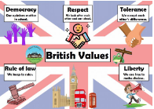

In the Early Years, the fundamental British Values are explored in ways that are meaningful to young children. Fundamental British values are important democratic values. Overall, the goal of these values is to enable people to be part of a democratic society and to help them to look after others around them. The Fundamental British Values are: Democracy The rule of law Individual liberty Mutual respect and tolerance of those of different faiths and beliefs.

Autumn 1 | Autumn 2 | Spring 1 | Spring 2 | Summer 1 | Summer 2
All About Me!   |   Celebrations and Traditions! |   Amazing Animals! |     Ticket to Ride! | Come Outside!   |   Fun at the Seaside!
Key texts to support key themes.
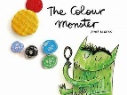  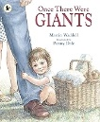  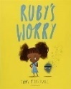  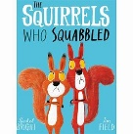  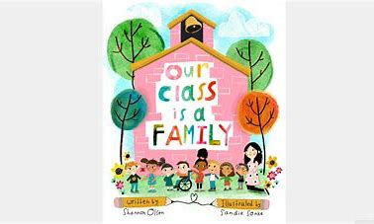  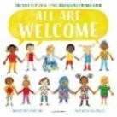 | 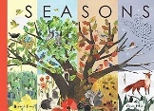  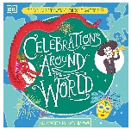  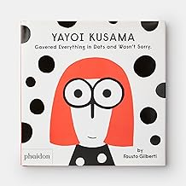  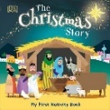   | 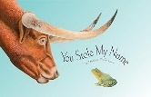  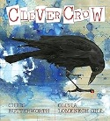  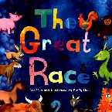  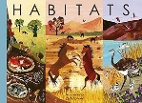  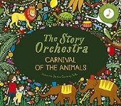  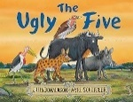 | 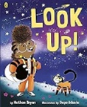  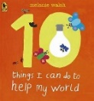  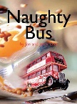  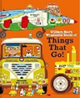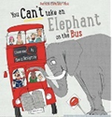  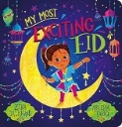  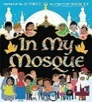 |   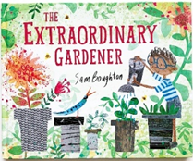  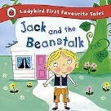  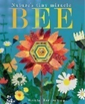  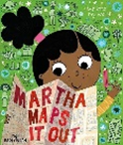 | 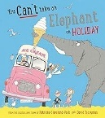  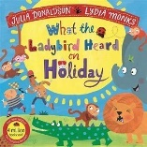  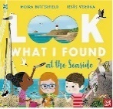  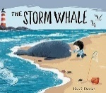  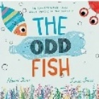  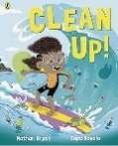
Communication and Language
Autumn |  | Spring |  | Summer
- Introduce carpet routines and rules to promote good listening  - Understand how to listen carefully and why listening is important.  - Promoting and modelling active listening skills  - Listen carefully to a variety of texts.  - Listening, responding and retelling stories. Answering who, what, where, when questions.  - Listening and Attention Games – Silly soup, listening bingo, alliteration, rhyming etc  - Following instructions  - Learn and use new vocabulary.  - Start conversations with adults / peers  - Encourage children to talk about experiences. |  | - Ask questions to find out more and to check  they understand what has been said to them.  - Engage in fiction and non-fiction texts.  - Describe some events in detail.  - Engage at story time.  - Using a wider range of vocabulary.  - Use talk to help work out problems and  organise thinking and activities.  - Enjoy listening to longer stories.  - Express their ideas and feelings about their  experiences using: full sentences, use of tenses  and making use of conjunctions.  - Articulate their ideas and thoughts in well formed sentences. |  | - Learn and use new vocabulary  - Listen attentively and respond to what they hear with relevant questions.  - Connect one idea or action to another using a range of connectives.  - Make comments about what they have heard and ask questions to clarify understanding.  - Learn and use new vocabulary in different contexts.  - Offer explanations for why things might happen.  - Hold conversations in back and forth exchanges with adults and peers.  - Participate in small group and class discussions, using new vocabulary.
Personal, Social and Emotional Development
Children’s personal, social and emotional development (PSED) is crucial for children to lead healthy and happy lives, and is fundamental to their cognitive development. Underpinning their personal development are the important attachments that shape their social world. Strong, warm and supportive relationships with adults enable children to learn how to understand their own feelings and those of others. Children should be supported to manage emotions, develop a positive sense of self, set themselves simple goals, have confidence in their own abilities, to persist and wait for what they want and direct attention as necessary. Through adult modelling and guidance, they will learn how to look after their bodies, including healthy eating, and manage personal needs independently. Through supported interaction with other children, they learn how to make good friendships, co-operate and resolve conflicts peaceably. These attributes will provide a secure platform from which children can achieve at school and in later life.

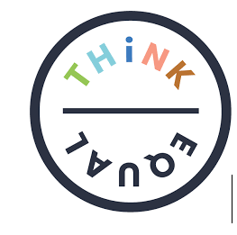
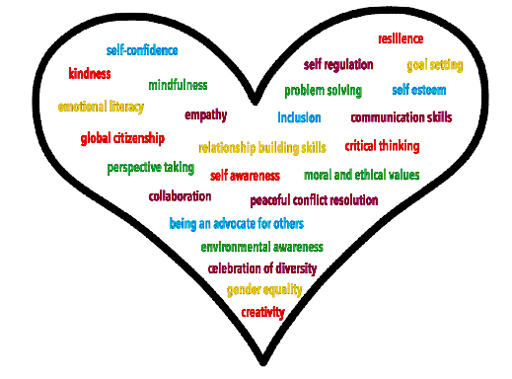
In EYFS we follow the ‘Think Equal’ Programme, a curriculum-based programme that supports social and emotional development in the early years. It is rooted in mental health and social justice and aims to build a strong foundation for individual and societal progress. This programme is fully aligned with the early years foundation stage (EYFS) curriculum and teaches 25 skills and competencies to help children through their Early Childhood Education.
Think Equal helps our children to:
- Manage their own emotions and impulsive behaviours
- Build their confidence and self-esteem
- Have empathy and show consideration for others
- Solve problems effectively and learn to resolve conflicts peacefully
- Build critical thinking skills and make responsible decisions
- Maintain healthy relationships and learn to collaborate

Designed by global experts in the fields of education, human rights, neuroscience and psychology, the ‘Think Equal’ programme is evidence-based, holistic, easy to use and impactful. It offers a narrative based approach and is delivered flexibly through a collection of picture books.
Autumn |  | Spring |  | Summer
- Marvellous Me  - These Feelings  - The Weather Inside Me!  - Ted The Tiger Tamer  - The Secret Adventures of Annonymouse  - Curly The Chameleon  - Ahmed’s Journey  - Faisal’s Not Himself |  | - Passing Clouds  - Yoshi Is Different  - Nisha And The Tiger  - Francisco’s Family  - Biyu The Brave Pea  - Thabo And The Trees  - The Monster In The Smoke  - A Tiny Seed: The Story Of Wangari Maathai |  | - Nothando’s Journey  - Reha To The Rescue  - Our Home  - Gokul’s Game  - Zelda Goes on Holiday  - My Dream in the Drawer  - Sydney the Seahorse  - Deji and Nnedi and the Very Large Cushion
Physical Development
Autumn |  | Spring |  | Summer
- Develop the skills they need to manage the day  successfully e.g. lining up, queuing etc.  - Manage personal hygiene.  - Ride bikes and scooters, developing agility.  - Go up steps and stairs, or climb up apparatus,  using alternate feet.  - Use large movements to wave flags, paint and  make marks.  - Be increasingly independent as they get dressed  and undressed, for example, putting coats on  and doing up zips  - Use one-handed tools and equipment, for  example, making snips in paper with scissors  - Use a comfortable grip with good control when  holding pens and pencils |  | - Further develop the skills they need to manage  the school day successfully: - lining up and  queuing – mealtimes  - Develop their fine motor skills so that they  can use a range of tools competently, safely  and confidently. Suggested tools: pencils for  drawing and writing, paintbrushes, scissors,  knives, forks and spoons  - Use their core muscle strength to achieve a  good posture when sitting at a table or sitting on the floor.  - Confidently use a range of large and small  apparatus indoors and outdoors.  Develop overall body-strength, balance,  coordination and agility.  - Begin to develop the foundations of handwriting style which is fast, accurate and efficient, consolidating effective pencil grip.  - Begin to form all letters correctly. |  | - Demonstrate strength, balance and  coordination when playing  - Hold a pencil effectively in preparation for  fluent writing – using the tripod grip  - Use a range of small tools, including scissors,  paintbrushes and cutlery  - Develop confidence, competence, precision and  accuracy when engaging in activities that  involve a ball.  - Develop the overall body strength,  coordination, balance and agility needed to  engage successfully in physical activities.  - Begin to show accuracy and care when  drawing
Primary PE Planning (PPE)
Autumn |  | Spring |  | Summer
Unit 1 - First PE  - Negotiate space in the hall and find a safe space on your own.  - Move energetically and run, jump, hop, skip, crawl into a space.  - Throw and catch a ball by spreading fingers into a basket.  Unit 2 – Gymnastics  - Experiment with different shapes, rolls and jumps.  - Experiment with balancing on different body parts  - Move along apparatus in different ways.  - Move on and off apparatus safely. |  | Unit 3 – Multi-Skills  - Develop balancing skills on your own, on an object/apparatus.  - Develop co-ordination skills with throwing and catching objects.  - Experiment with different ways of moving, developing agility and speed.  - Work with friends in a team and take turns.  Unit 4 – Dance  - Experiment with different ways of moving to music whilst negotiating space.  - Move in different directions and in time to music.  - Begin to create dances on their own and in pairs and perform to a group. |  | Unit 5 – Athletics  - Experiment with different ways of jumping and begin to jump over objects.  - Experiment with different ways of throwing under/overarm  - Learn how to throw objects into targets.  - Take part in fun competitions against their friends.  Unit 6 – Olympic Dance  - Learn about the Olympics and the sports involved  - Experiment with different ways of moving to music whilst negotiating space.  - Move in different directions and in time to music.  - Begin to create dances on their own and in pairs and perform to a group.  - Become a mini-coach and give feedback to friends about their performance.
Literacy

Phonics – Read Write Inc

We follow ‘Read Write Inc’ (RWI), which is a systematic synthetic phonics scheme. Following 4 weeks of whole class teaching in Autumn 1, the children are then streamed into smaller ability groups across Reception.
Reading
Autumn |  | Spring |  | Summer
- Join in with nursery rhymes and songs, and  show an interest in stories.  - Develop phonological awareness of the initial sounds in words, rhyming, alliteration and syllable clapping.  - Recognise own name  - Hear and say initial sounds in words  - Begin to orally blend cvc words (Fred Talk)  - Sequence and retell familiar fiction and  non-fiction texts.  - Read individual letters (set 1) by saying the  sounds for them, in line with RWI.  - Blend sounds into words, so they can read cvc  words. |  | - Begin to read ‘red tricky words’.  - Begin to recognise set 2 ‘Special Friends’, in  line with RWI.  - Engage in extended conversations about  stories, learning new vocabulary.  - Read simple words, phrases and sentences,  containing some ‘red’ tricky words  - Be able to answer simple questions about the  text they have read  - Develop fluency and speed when reading. |  | - Re-read books to build up their confidence in  word reading, fluency, understanding and enjoyment.  - Re-read what they have written, to check it  makes sense.  - Demonstrate understanding of what has been  read to them by retelling stories and  narratives using their own words and recently  introduced vocabulary  - Use and understand recently introduced  vocabulary during discussions about stories,  nonfiction, rhymes and poems and during role play  - Read words consistent with their phonic knowledge by sound-blending
Writing
Ready Steady Write
Key Texts
The Something  Rebecca Cobb  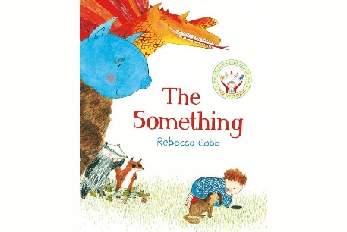 | Star in a Jar  Sam Hay  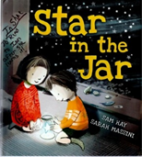 | Juniper Jupiter  Lizzy Stewart  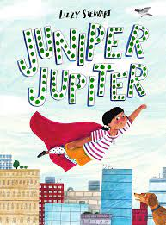 | Little Red  Bethan Woolvin  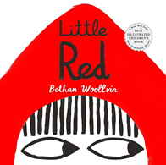 | The Extraordinary Gardener  Sam Boughton  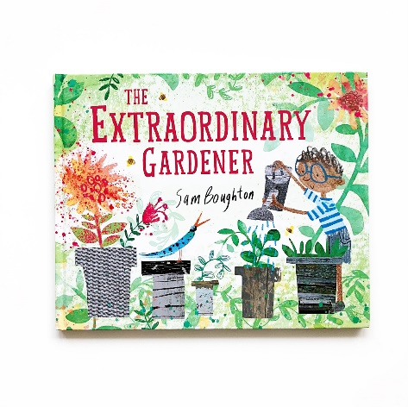 | The Storm Whale  Benji Davies  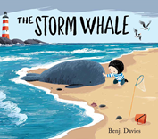
Autumn |  | Spring |  | Summer
- Experimenting with mark-making and writing  patterns, in a range of mediums.  - Begin to develop a dominant hand and work  towards the tripod grip.  - Children will start to give meaning to marks  they make.  - Letter formation of RWI Set 1 Sounds.  - Begin to orally blend sounds in cvc words using Fred Talk.  - Write initial sounds in words.  - Write own name. |  | - Continuing to practice letter formation.  - Write cvc words independently using Fred Fingers to support.  - Write labels and lists.  - Orally rehearse sentence before writing.  - Write simple sentences using known grapheme/phoneme correspondence.  - Include finger spaces  - Know that a sentence starts with a capital letter and ends with a full stop.  - Begin to write a variety of fiction and non-fiction sentences/captions. |  | - Write recognisable letters (lower case and capital) most of which are formed correctly.  - Spell words by identifying the sounds and then writing the sound with letter/s, using taught Grapheme/Phoneme correspondence.  - Write simple phrases and sentences that can be read by others.  - Orally rehearse sentence before writing.  - Include finger spaces, full stop and a capital letter.  - Create their own stories and books, with images and sometimes with words.  - Begin to sequence 2-3 sentences within purposeful fiction/ non-fiction writing
Maths – Mastery in Number & White Rose Maths
Autumn |  | Spring |  | Summer
Mastering Number - Lessons focus on subitising, counting, ordinality and cardinality, composition and comparison

White Rose Maths – Units of Work
Match, Sort and Compare  Talk About Measure and Patterns  It’s Me 1, 2, 3  Circles and Triangles  1,2,3,4,5  Shapes with 4 sides |  | Alive in 5  Mass and Capacity  Growing 6,7,8  Length,height and Time  Building 9 and 10  Explore 3D Shapes |  | To 20 and Beyond  How Many Now?  Manipulate, Compose and Decompose  Sharing and Grouping  Visualise, Build and Map
- Matching, Sorting and Comparing  - Comparing size, mass and capacity  - Copying and continuing simple patterns  - Finding, representing and subitising numbers 1, 2, 3, 4, and 5  - Composition of 1, 2, 3, 4 and 5  - Finding 1 more and 1 less than a given number  - Comparing quantities and sets, using the language of comparison e.g. ‘more/fewer than  - Identifying, naming and comparing circles and triangles  - Identifying and naming shapes with 4 sides  - Exploring shapes in the environment  - Exposing children to different representations e.g. Numicon, counters, dice patterns etc  - Develop 1:1 correspondence, when counting  - Matching numerals to quantities 0-5  - Number formation practice  - Introduction to part-part whole models |  | - Introduce zero.  - Continue to find, subitise, represent and compose numbers to 5  - Counting to 10 and beyond  - Exploring the composition of numbers to 10  - Ordering numbers on a Number Line and with Numicon  - Matching numerals to quantities within 1-10  - Number formation practice  - Introduce the concept of doubling within 10  - Exploring height, weight and length  - Odd and Even Numbers  - Exploring 3D Shapes |  | - Subitise up to 5 without counting.  - Understand the composition of numbers to 10.  - Automatically recall number bonds for numbers 0-5 and some to 10.  - Understand the pattern of double numbers.  - Verbally count beyond 20, recognising the pattern of the counting system.  - Introduce addition and subtraction.  - Sharing and grouping.  - Matching numerals and quantities within 1- 20.  - Exploring numbers beyond 10.  - Representing tricky ‘teen’ numbers.  - Compose and decompose shapes, so children can recognise a shape can have other shapes within it.  - Expose the children to numbers to 100.  - Introduce the rekenrek
Understanding the World
Autumn |  | Spring |  | Summer
People, Culture and Communities
- Begin to make sense of their own life-story and family’s history.  - Talk about members of their immediate family and share photographs.  - Recognise the differences between themselves and their friends.  - Recognise that people have different beliefs and celebrate special times in different ways.  - Talk about different celebrations and traditions e.g Halloween, Bonfire night, Remembrance Sunday,  - Develop an awareness and talk about some key celebrations e.g. Rosh Hashanah, Diwali, Halloween, Bonfire Night, Remembrance Day, St Andrew’s Day, Hanukkah, Christmas etc.  - Talk about people in our community and the jobs that they do. (teachers, nurses, doctors, shopkeepers etc.) |  | - Talk about immediate family members, pets and their community.  - Talk about what they do with their family and places they have visited.  - Recognise that people have different beliefs and celebrate times in different ways.  - Talk about journeys that they have been on with their families and how they travelled.  - Know how transport has changed over time.  - Develop an awareness and talk about some key celebrations e.g. Chinese New Year, St David’s Day, St Patrick’s Day, Mother’s Day, Shrove Tuesday, Ash Wednesday, Holi, Mother’s Day, Ramadan, Eid-al-Fitr and Easter.  - Talk about people in our community and the jobs that they do. (Librarians, gardeners, vets, etc.)  - Visit the local Library and understand that it is a place that they can visit within their local community. |  | - Talk about what they do with their family and places they have visited with their family.  - Talk about their local area and places to visit.  - Recognise that people have different beliefs and celebrate times in different ways.  - Develop an awareness and talk about some key celebrations e.g. St Georges Day, Father’s Day, Pride month, Shavuot, Eid-Al-Adha  - Visit the local church and understand that it is a place of Worship for Christians.  - Talk about people in our community and the jobs that they do. (Police officers, bus,train,taxi drivers, pilots, firefighters etc.)
Past and Present
- Begin to understand, follow, use and talk about the daily routine using a visual timetable …morning, afternoon, next, in between.  - Begin to recite the days of the week.  - Begin to be aware of the months of the year.  - Know that different things that happen on different days of the week… yesterday, today, tomorrow  - Begin to understand that their birthday and some key festivals are annual and take place at different times of the year…birthday, Christmas, Eid, Hanukah, Diwali,  - Begin to understand that there are four seasons across the year …autumn, winter, spring, summer.  - Know that bonfire night takes place in autumn and the nights are longer.  - Understand, predict and talk about key events to complete an activity.  - I can talk about how to complete a simple activity.  - Begin to use some sequencing vocabulary… first, last, day, night.  - Begin to talk about duration e.g. quick / short / long story or activity.  - Begin to understand when things happen… past, present, future.  - Begin to make sense of their own life-story and family’s history - Identifying their family, family name / surname, extended family… grandparents, aunts, uncles, cousins.  - Begin to share key family events and celebrations.  - Talk about how I have changed since being a baby. I know that my parents and grandparents were once babies and children.  - Begin to talk about past and present events in their own life and the lives of family members.  - Share family celebrations past and present. Familiar situations from the past Comment on images of familiar situations in the past.  - Begin to know some similarities and differences between things in the past and now, drawing on their experiences and what has been read in class.  - Begin to understand the past through settings, characters and events encountered in books, nursery rhymes and storytelling.  Share the story Peepo and make links to the past.  - Talk about Significant figure from the past: Guy Fawkes |  | - Predict what might happen next within the daily routine with some accuracy and understanding.  - Continue to use the names of the months.  - Know that there are four seasons across the year.  - Use some sequencing vocabulary… before, next, after, early, later.  - Begin to use comparative language to measure time… shorter, longer, quicker, slower.  - Begin to understand when things happen… (see autumn) e.g. last week, yesterday, today, tomorrow.  - Begin to use words to explain when events have happened / will happen… past, present, future. Continue to talk about past and present events in the context of their home / school life.  - Discuss and share key achievements since starting school.  - Know some similarities and differences between things in the past and now, drawing on their experiences and what has been read in class  - Figures, characters, settings and events from the past  - Talk about the past settings, characters and events encountered in books, nursery rhymes and storytelling.  - Begin to use some sequencing vocabulary |  | - Begin to use a monthly calendar. E.g. count how many sleeps or days until…  - Begin to recite the months of the year.  - Know that there is a repeated cycle of seasons.  - With support identify the most significant / important events of the reception year.  - Understand how holidays changed over time.  - Talk about the lives of the people around them and their roles in society (see Occupations – PC&C). Figures, characters, settings and events from the past  - Talk about the past through settings, characters and events encountered in books read in class and storytelling.  - Talk about significant figure from the past: David Attenborough …famous, important.  - I can talk about how trees and plants change through the different seasons.
Natural World
- Talk about signs of Autumn and Winter  - Understand the effect of changing seasons on the natural world around them  - Describe what they see, hear and feel whilst outside.  - Talk about how we can care for our world, school, classroom.  - Talk about recycling and picking up litter.  - Explore the outdoors and experience the natural world in the Willow Garden  - Talk about animals and insects that live in the Uk.  - Talk about how animals adapt to the seasons and how some animals hibernate.  - Talk about the Arctic and Antarctic. Discuss contrasting environments e.g. Arctic vs UK  - Observe changes e.g. Melting and Freezing. |  | - Talk about signs of Spring.  - Understand the effect of changing seasons on the natural world around them  - Describe what they see, hear and feel whilst outside.  - Talk about the weather and record changes on a weather chart.  - Talk about different animals and their habitats.  - Talk about how animals and plants adapt to their environments.  - Explore forces – pushes and pulls.  - Recognise some similarities and differences between life in this country and life in other countries.  - Explore the outdoors and experience the natural world in the Willow Garden |  | - Talk about signs of Spring.  - Understand the effect of changing seasons on the natural world around them  - Describe what they see, hear and feel whilst outside.  - Talk about the weather.  - Looking after the environment e.g. Plastic pollution  - Explore floating and sinking.  - Compare similarities and differences of holidays in the UK and other countries.  - Explore sound and vibrations.  - Explore the outdoors and experience the natural world in the Willow Garden  - Talk about what a plant needs to grow.  - Talk about different insects and how they help plants to grow.  - Talk about how we can care for our world.  - Talk about tips to help save the planet e.g recycling, use less energy etc.
Field Work
Investigating our school using locational language
Where is Fred Frog? Use locational language to describe where Fred is.
Investigate maps -classroom map, school map, maps of a zoo
Draw a simple classroom map and use symbols.
Make models of zoos and use locational language to describe how to get to the different animal enclosures.
Look at aerial views of
Take aerial photos of zoo models. Discuss ‘Bird’s Eye View’ and its meaning.
Draw maps of a zoo and use locational language to talk about their maps.
Explore the outdoors.

What is the weather like today?
What do we know about the weather?
What are clouds and why does it rain?
How are rainbows made?
What are weather symbols? When are they used?
What is a weather forecast? Watch the weather forecast for tomorrow and talk about what you might need to wear.
Look at local weather maps.
What is the weather like in Spring?
Create a weather chart for the classroom and talk about what the weather is each day/the next day. Add weather symbols to the chart.
Explore the outdoors and changes in the weather.

Investigating our Local Area
Investigate maps of the local area.
Use goggle maps to familiarise children with their local area.
Look at aerial views of the school setting, encouraging children to comment on what they notice, recognising buildings, open space, roads and other simple features.
Draw simple maps of their environment.
Draw imaginary maps for familiar story settings.
Explore the outdoors.

Beliefs and Values
Autumn |  | Spring |  | Summer
What people are special and why?  - To be able to talk about people who are special to them  - To be able to say what makes their family and friends special to them  - To be able to identify some of the qualities of a good friend  - To be able to recall and talk about stories of Jesus as a friend to others  - To be able to recall stories about special people in other religions and talk about what we can learn from them.  What times are special and why?  - To be able to give examples of special occasions and suggest features of a good celebration  - To be able to recall simple stories connected with Christmas and a festival from another faith.  - To be able to say why Christmas and a festival from another faith is a special time for Christians and members of other faiths.  - To be able to talk about information on the festivals of different religious communities of the UK |  | What stories are special and why?  - To be able to talk about some religious stories  - To be able to use some religious words, e.g. God, Jesus, Bible, Christian, Prophet. Muhammad, Muslim  - To be able to identify some of their own feelings in the stories they hear  - To be able to name a sacred text and religion, e.g. ‘the Bible is for Christians’ ‘The Qur’an is for Muslims’  - To be able to talk about what Jesus  - and Muhammad taught people about keeping promises, being thankful or being kind  - To be able to share ideas about the experiences of thanking and being thanked, praising and being praised  What is special about our world and why?  - To be able to talk about things they find interesting, puzzling or wonderful and also about their own experiences and feelings about the world  - To be able to re-tell stories, talking about what they say about the world, God and human beings.  - To be able to think about the wonders of the natural world, expressing ideas and feelings  - To be able to express ideas about how to look after animals and plants  - To be able to talk about what people do to mess up the world and what they do to look after it |  | Which places are special and why?  - To be able to talk about somewhere that is special to themselves, saying why  - To be able to be aware that some religious people have places which have special meaning for them  - To be able to talk about the things that are special and valued in a place of worship  - To be able to identify some significant features of sacred places  - To be able to recognise a place of worship  - To be able to know a similarity and a difference between two different places of worship.  Where do we belong?  - To be able to re-tell religious stories making connections with personal experiences of belonging  - To be able to share and record occasions when things have happened in their lives that made them feel special  - To be able to recall simply what happens at a traditional Christian infant baptism and dedication  - To be able to recall simply what happens when a baby is welcomed into Islam  - To be able to hold conversations about special religious signs of belonging, using new vocabulary  - To be able to talk about the lives of other people using simple ideas about the experiences of belonging and  - community  - To be able to talk about the different ways religious communities of the UK welcome a new baby
Creative Arts and Design
Autumn |  | Spring |  | Summer
- Begin to draw with purpose, deciding what to draw before making marks.  - Use a variety of mark-makers with increasing control and efficiency.  - Understand that they can draw through observation  - Make Observational drawings using a range of media – pencils, chalk, pastels, charcoal, graphite.  - Draw and paint a self potrait using mirrors.  - In painting, be able to select a brush and use a ‘dip, draw, wash and wipe’ technique to keep colours clear.  - Explore what happens mixing primary colours to create secondary colours.  - Begin to explore a range of painting techniques  - Begin to print using objects and paint.  - Use a range of materials to make models – e.g musical instruments, vehicles.  - Join materials using different techniques, glues and tapes, string.  - Use a range of tools e.g scissors, hole punches  - Mould clay/dough with hands using techniques such as pinching, squeezing, pulling, poking, patting to achieve a desired effect (e.g. sausages, balls, thumb pot). Use tools appropriately to roll, cut, flatten etc.  - Talk about artists work and techniques.  - Create artwork in the style of an artist.  - Collaborate to create artwork as a group.  - Display artwork in the class Art Gallery. |  | - Develop drawing within a range of contexts (e.g. telling a story, figurative or responding to the way an object moves or feels).  - Make Observational drawings using a range of media – pencils, chalk, pastels, charcoal, graphite.  - Mix various shades of primary colours to create secondary colours and use these in artwork.  - Observe animals and make observational drawings.  - Combine a variety of media e.g pencils, paint, chalk, pastels, charcoal, graphite.  - Explore a range of painting techniques using a selection of tools – e.g brushes, sticks, fingers, corks.  - Draw and paint on a larger scale both indoors and out.  - Use flowers and plants as a stimulas for drawing and painting.  - Explore different textures and create a collage.  - Use fabrics, yarns, other materials to create weavings.  - Use loose parts and natural resources to create transient art.  - Talk about artists work and techniques.  - Create artwork in the style of an artist.  - Collaborate to create artwork as a group. |  | - Explore, use and refine a variety of artistic effects to express their ideas and feelings.  - Use colour-mixing techniques, to match the colours they see and want to represent.  - Combine a variety of media e.g pencils, paint, chalk, pastels, charcoal, graphite.  - Choose a painting technique and tool to create own artwork.  - Draw and paint on a larger scale both indoors and out.  - Make models for a purpose  - Use a range of recycled materials to make models – e.g musical instruments, vehicles.  - Join materials using different techniques, glues and tapes, string.  - Use a range of tools e.g scissors, hole punches  - Cut shapes from a range of papers and create own collage.  - Talk about artists work and techniques.  - Make Observational drawings using a range of media – pencils, chalk, charcoal, graphite.  Independently assemble different pieces to create a picture or pattern. Use imagination / observation, building on their previous learning, to represent their ideas.  - Talk about artists work and techniques.  - Share artwork/creations and talk about own work.  - Create artwork in the style of an artist.  - Collaborate to create artwork as a group.
Creative Arts and Design - Key Texts
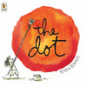  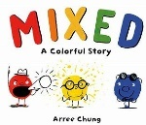    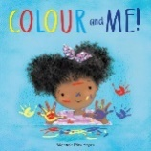  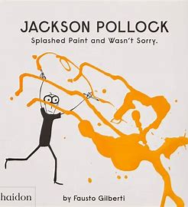 |  | 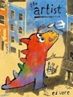  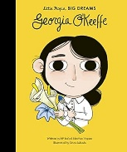  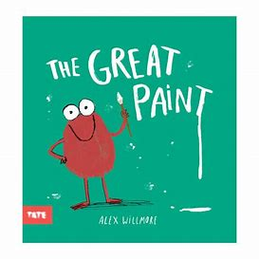  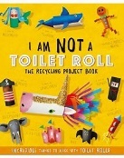  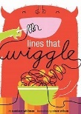  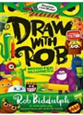 |  | 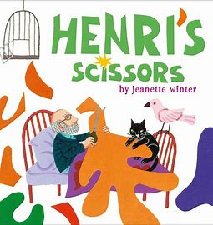  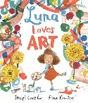  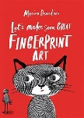  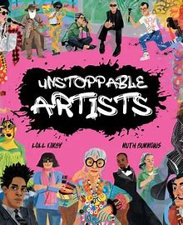  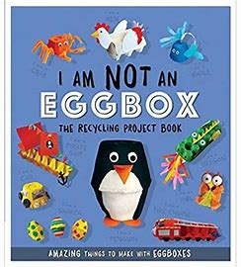  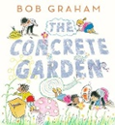
Music - Kapow
Autumn |  | Spring |  | Summer
Exploring Sound  Exploring how to use our voice and bodies to make sounds, experimenting with tempo and dynamic when playing instruments and identifying sounds in the environment.  Celebration Music  Learning about the music from a range of cultural and religious celebrations, including Diwali, Hanukkah, Kwanzaa and Christmas. |  | Music and Movement  Creating simple actions to songs, learning how to move to a beat and expressing feelings and emotions through movement to music.  Musical Stories  A unit based on traditional tales and songs, where pupils learn that music and instruments can be used to convey moods or represent characters. |  | Transport  Using their voices, bodies and instruments to explore different types of transport, identify and mimic transport sounds and interpret and perform a simple score.  Big Band  Learning about the four different groups of musical instruments, following a beat using an untuned instrument and performing a practised song to a small audience.

End of Year Expectations for Reception – Early Learning Goals (ELG’s)
